PREDICTION OF HEAVY/HIGH IMPACT RAIN EVENTS USING SATELLITE DATA

A PROJECT REPORT

Submitted by

Abhishek Rana (20BCS3818)

Ashutosh Kumar Singh (20BCS3804)

Sumit Choudhary (20BCS3829)

in partial fulfillment for the award of the degree of

BACHELOR OF ENGINEERING

IN

COMPUTER SCIENCE AND ENGINNERING

Chandigarh University
April 2024

BONAFIDE CERTIFICATE

Certified that this project report “PREDICTION OF HEAVY/HIGH IMPACT RAIN EVENTS USING SATELLITE DATA” is the bonafide work of “Abhishek Rana (20BCS3818), Ashutosh Kumar Singh (20BCS3804), Sumit Choudhary (20BCS3829)” who carried out the project work under my/our supervision.

Mrs. Shweta Thakur
SUPERVISOR SIGNATURE

TABLE OF CONTENTS
 | Chapter No. |  | Title |  | Page No.
 |  |  | Title Page |  | i
 |  |  | Abstract |  | ii
 |  |  | Graphical Abstract |  | iii
 |  |  | List of Figures |  | iv
 |  |  | List of Tables |  | v
 | 1 |  | Introduction |  | 1
 |  | 1.1 Observation |  | 1
 |  | 1.2 Exiting System |  | 1
 |  | 1.3 Objective |  | 3
 | 2 |  | Literature Survey |  | 5
 | 3 |  | Problem Formulation |  | 8
 | 4 |  | Methods |  | 12
 |  | 4.1 Proposed System |  | 12
 |  | 4.2Methodology |  | 15
 |  | 4.3 Code Overview |  | 26
 | 5 |  | Results and Outputs |  | 30
 | 6 |  | Conclusion |  | 39
 |  | 6.1 Introduction |  | 39
 |  | 6.2 Model Showcase |  | 39
 |  | 6.3 Linear regression |  | 39
 |  | 6.4 The Evaluation |  | 40
 |  | 6.5 The Delicate Balancing Act |  | 40
 |  |  | 6.6 The Read Ahead |  | 40
 | 7 |  | Future Scope |  | 41
 |  |  | 7.1 Introduction |  | 42
 |  |  | 7.2 Enhance Resolution |  | 42
 |  |  | 7.3 Interdisciplinary Collaboration |  | 43
 |  |  | 7.4 Conclusion |  | 44
 | 8 |  | References |  | 47

Abstract
The frequency and intensity of heavy rain events have increased globally, posing significant challenges to various sectors including agriculture, infrastructure, and disaster management. Timely prediction of these events is crucial for effective preparedness and mitigation strategies. Satellite data has emerged as a valuable tool for monitoring and predicting weather patterns, including heavy rain events. This study focuses on the development of predictive models utilizing satellite data to forecast heavy/high impact rain events. By using traditional models such as linear regression, SVM with comparison with more advance techniques like RNN, we aim to verify whether Neural Networks perform better than the traditional approaches. By comparing different models, we identify RNN to performed better than other models with MAE (Mean Absolute Error) of 85.50177457045439 which is significantly less than other traditional approaches, hence is capable of providing better insight for rainfall prediction and better accuracy, helping in high impact rainfall preparedness, agriculture, and disaster management.

Keywords—Heavy rain events, High impact, Satellite data, Remote sensing, Feature selection, Environmental variables, Early warning systems, Rainfall Prediction, disaster Management

Graphical Abstract
Heat Map of monthly rainfall amount aiding in finding corelation between features
Graph for predicted and Actual Rainfall using Linear Regression

List of Figures
Figure 3.1 ……………………………………………………… Forward Pass RNN
Figure 3.2 …………………………………………………………. Back-Pass RNN
Figure 3.3 ………………………………………………………… SVM Model
Figure 3.4 ……………………………………………… Model Summary for NN
Figure 3.5………………………………………………………. Library Import
Figure 3.6 ……………………………………………Function for Plotting Graphs
Figure 3.7 ……………………………………………………Forward Pass in RNN
Figure 3.8 ………………………………………………………...Test & Train Split
Figure 3.9 ………………………………………………………………………SVM
Figure 3.10 ……………………………………………………………………RNN
Figure 3.11 ………………………………………………………Segregation of data
Figure 3.12 ……………………………………Train and Test For Andhra Pradesh
Figure 4.1 ………………………………………Distribution of rainfall over years
Figure 4.2 …………………………Show the distribution of rainfall over models
Figure 4.3 …………………………Show the distribution of rainfall over quarter
Figure 4.4 ……The Rainfall is reasonably good in second quarter in eastern India
Figure 4.5 Heat Map showing the correlation between rainfall amount over different models
Figure 4.6 Heat Map showing the correlation between rainfall amount over different models
Figure 4.7 Graph Showing the comparison between the prediction and ground truth of the rainfall
Figure 4.8 ……………………………………………Training Loss and Accuracy

List of Tables
Table 1.1 ……………………………………………Dataset for Average Rainfall
Table 2.1 ……………………………………………Tabulated Literature Survey

CHAPTER 1
- INTRODUCTION

1.1 Observation
In recent years, there has been a notable increase in both the frequency and intensity of heavy rain events, a trend that is partially attributed to climate variability and the melting of glaciers. These events, characterized by high rates of precipitation over short periods, pose significant threats to various industries, including infrastructure, human settlements, and agriculture. It is imperative to predict rain occurrences accurately and promptly to ensure successful disaster response, preparation, and mitigation.

1.2 Existing System
Traditional weather forecasting methods primarily rely on numerical weather models and ground-based observations, as well as statistical approaches. However, these methods often encounter challenges in accurately describing localized episodes of intense rain based on past observations. In contrast, satellite data provides regular observations and extensive spatial coverage, proving to be an invaluable tool for tracking and predicting weather trends. The utilization of satellite data assists in the development of disaster prevention systems managed by responsible bodies of different states.
Recent progressions in remote sensing technologies and advancements in machine learning algorithms have facilitated the prediction of heavy rain events through the utilization of satellite data. Measurements of precipitation derived from satellites, employing sensors like radar and infrared devices, provide vital insights into both the spatial distribution and quantity of rainfall. Leveraging this data, models can be trained to anticipate weather patterns, with a specific focus on heavy rain occurrences.

The integration of satellite data into predictive modeling endeavors marks a significant advancement in weather forecasting capabilities. By harnessing information gathered from satellite sensors, such as radar and infrared devices, researchers gain access to comprehensive datasets detailing precipitation levels and patterns. These datasets serve as foundational elements for developing models capable of forecasting heavy rain events with greater accuracy and precision.

Satellite-based estimates of precipitation, derived from advanced sensors such as radar and infrared devices, furnish invaluable insights into the dynamics of rainfall patterns. Through meticulous analysis of this data, researchers can discern trends and patterns indicative of heavy rain events. By training machine learning models on this satellite-derived data, forecasters can enhance their ability to predict heavy rain occurrences, thereby facilitating proactive measures for disaster preparedness and mitigation.

The utilization of satellite data, coupled with machine learning algorithms, enables researchers to extract meaningful insights into weather dynamics, particularly with regard to heavy rain events. By leveraging the wealth of information provided by satellite sensors, such as radar and infrared devices, researchers can develop sophisticated models capable of accurately forecasting heavy rain occurrences. This integration of satellite data and machine learning algorithms represents a significant advancement in weather forecasting capabilities, enabling more precise predictions of heavy rain events and better preparedness for associated risks.

  - Objective
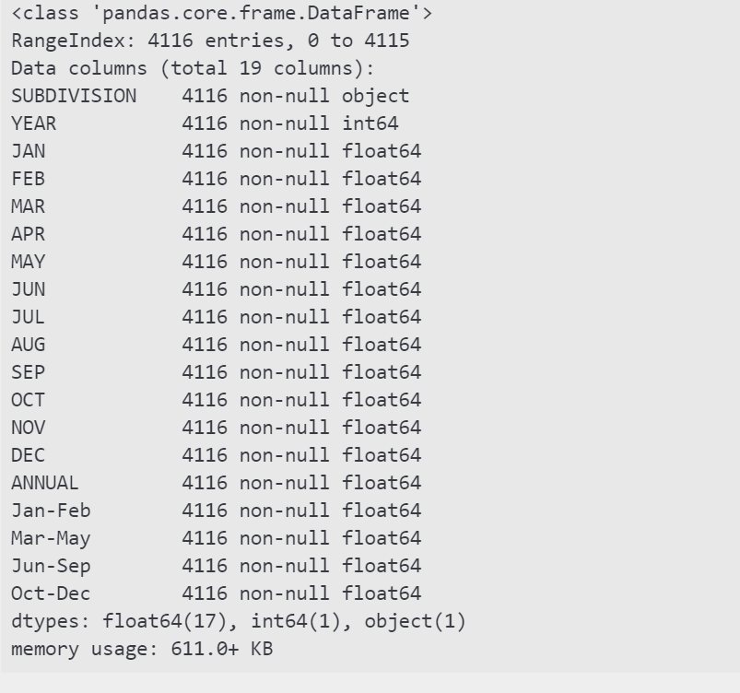
Table1.1 Dataset for average rainfall for every year from 1901-2015 for each state.
The objective of this machine learning project is to develop various prediction models for anticipating rain events with high potential impacts by leveraging satellite data and machine learning approaches. By training and comparing various models, the aim is to identify the most suitable approaches for different geographical scales, including country-wide, state-wise, and district-wise rainfall analyses.
This research holds significant importance as it has the potential to enhance tactics for catastrophe risk reduction and early warning systems. Decision-makers can more effectively allocate resources and implement preparatory measures to mitigate the negative effects of heavy rain occurrences on vulnerable populations and vital infrastructure. Timely and accurate forecasts of heavy rain events enable proactive planning for disaster prevention measures.
Furthermore, the models developed in this project not only provide independent results but can also be evaluated by forming ensembles to neutralize the drawbacks of each approach used independently. This approach further increases the accuracy rate of heavy rainfall event predictions.
In conclusion, the increase in heavy rain events poses significant challenges to various sectors, necessitating accurate and timely predictions for effective disaster response and mitigation. Satellite data and machine learning algorithms offer promising avenues for improving forecasting capabilities. By leveraging these technologies, decision-makers can better prepare for and respond to heavy rain events, thereby reducing the negative impacts on communities and infrastructure. This research contributes to the advancement of disaster preparedness and early warning systems, ultimately enhancing resilience to extreme weather events.
Title: Leveraging Satellite Data and Machine Learning for Heavy Rain Event Prediction: Enhancing Disaster Resilience through Data-Driven Approaches

Introduction:
In recent years, the intersection of satellite data and machine learning techniques has emerged as a powerful tool for predicting heavy rain events. This project aims to develop and compare various prediction models tailored to different geographical scales, ranging from country-wide to district-wise analyses. By leveraging these models, decision-makers can enhance disaster risk reduction strategies and improve early warning systems, ultimately mitigating the negative impacts of heavy rain occurrences on vulnerable populations and critical infrastructure.

Importance of the Research:
The significance of this research lies in its potential to revolutionize disaster preparedness and response efforts. Timely and accurate forecasts of heavy rain events empower decision-makers to allocate resources effectively and implement preparatory measures to mitigate risks. By providing independent results and employing ensemble methods to combine multiple models, this project enhances the reliability and accuracy of predictions, thereby strengthening disaster resilience at various levels of governance.

Satellite Data and Machine Learning Approaches:
Satellite data offer a wealth of information, including precipitation patterns, atmospheric conditions, and land surface characteristics, which are essential for predicting heavy rain events. Machine learning techniques, such as supervised learning algorithms (e.g., random forests, support vector machines) and deep learning models (e.g., convolutional neural networks), enable the extraction of meaningful patterns from these vast datasets. By training these models on historical weather data and satellite imagery, researchers can develop predictive algorithms capable of forecasting heavy rain events with high precision.

Geographical Scale Analysis:
One of the key aspects of this project is the consideration of geographical scale. Different regions may exhibit distinct climatic patterns and terrain features, necessitating customized prediction models. By conducting analyses at the country-wide, state-wise, and district-wise levels, researchers can tailor their models to specific geographical contexts, thereby improving the accuracy and relevance of predictions for local stakeholders.

Enhancing Early Warning Systems:
Early warning systems play a pivotal role in mitigating the impact of natural disasters. By integrating satellite-derived data and machine learning models into existing warning systems, decision-makers can issue timely alerts and advisories, enabling communities to take proactive measures to safeguard lives and assets. Moreover, the ability to anticipate heavy rain events with greater accuracy enhances public trust in these systems, fostering a culture of preparedness and resilience.

Disaster Risk Reduction Strategies:
Effective disaster risk reduction strategies require a comprehensive understanding of potential hazards and their associated risks. By harnessing the predictive power of machine learning models, researchers can identify areas prone to heavy rain events and prioritize resource allocation for mitigation efforts. From infrastructure improvements to land use planning and community-based interventions, informed decision-making based on accurate forecasts can significantly reduce vulnerability to extreme weather events.

Ensemble Methods for Prediction:
Ensemble methods offer a robust approach to prediction by combining the strengths of multiple models while mitigating their individual weaknesses. By forming ensembles of prediction models, researchers can improve the reliability and robustness of forecasts, especially in complex and dynamic environments. Techniques such as model averaging, stacking, and boosting enable researchers to harness the collective intelligence of diverse models, resulting in more accurate predictions of heavy rain events.

Conclusion:
In conclusion, the integration of satellite data and machine learning techniques holds immense promise for enhancing disaster resilience through improved prediction of heavy rain events. By developing and comparing prediction models at various geographical scales, this research enables decision-makers to tailor their strategies to local contexts and allocate resources effectively. Furthermore, the use of ensemble methods enhances the reliability and accuracy of forecasts, thereby strengthening early warning systems and disaster risk reduction efforts. Ultimately, this project contributes to a more proactive and adaptive approach to managing the impacts of extreme weather events, safeguarding lives and livelihoods in an increasingly unpredictable climate.

CHAPTER 2
- LITERATURE SURVEY

- “Nishchala C Barde and Mrunalinee Patole [1]. Classification and forecasting of weather using ann, k-nn and naive bayes algorithms “. In This paper, here some algorithms are used to predict the rainfall. K-NN, ANN, and Naïve bayes algorithms are used to predict the weather.

- SML Venkata Narasimhamurthy & et al [2]. “Rice Crop Yield Forecasting Using Random Forest Algorithm”. Highest accuracy of 85.89% is obtained by using this method. In this paper gives good accuracy for crop prediction using rainfall prediction model.

- Dr. Bharat Mishra & et al [3]. “Soybean Productivity Modelling using Decision Tree Algorithms”. Decision tree is being converted to classification rules using IF-THEN- ELSE. In this model tries to give good prediction for crops. Here data mining techniques are used to building the model.

- K Chowdary, R Girisha, and KC Gouda [4] . “A study of rainfall over India using data mining”. Some datamining techniques are used to predict the output in future.

- Pinky Saikia Dutta and Hitesh Tahbilder [5]. “Prediction of rainfall using data mining technique over assam “. This paper done based on datamining techniques are using to trained the model for rainfall. and some techniques are used such as statistical techniques , multilinear regression . this model predicts rainfall basedon month in assam.

- Arun Kumar & et al [6]. “Efficient Crop Yield Prediction using rainfall Using Machine Learning Algorithms”. In this paper includes rainfall prediction And the range of productivity will be defined.

- Kawsar Akhand & et al [7]. “Yield Prediction using rainfall in Bangladesh Using
Satellite Remote Sensing Data and Artificial Neural Network”. In this machine learning algorithms are used to test the datasets and also used for predicting the system.

- P. Priya*1 & et al [8]. “Predicting the Crop Yield Using Machine Learning Algorithm”. in this paper having dataset cleaning, testing are done using machine learning algorithms and Decision tree is used for classification purposes.

- Ramírez, M. C. V., H. F. D. C., Velho and N. J. Ferreira, 2005. “Artificial neural network technique for rainfall forecasting applied to the São Paulo region”, Journal of Hydrology, 301(1-4), pp: 146–162. DOI: http://dx.doi.org/10.1016/j.jhydrol.2004.06.028

- Baareh, M.A.K., A. F. Sheta and Kh. Al Khnaifes, 2006, “Forecasting River Flow in the USA: A Comparison between Auto-Regression and Neural Network Non-Parametric Models”, Journal of Computer Science, 2 (10), pp: 775-780.

- Xiong, L. and K. M. O'connor, 2002, “Comparison of four updating models for real-time river flow forecasting”, Hydrological Sciences-Journal-des Sciences Hydrologiques, 47(4), pp: 621-639.

- Mohammadi, K., H.R. Eslami and S. Dayyani Dardashti, 2005. “Comparison of Regression ARIMA and ANN Models for Reservoir Inflow Forecasting using Snowmelt Equivalent (A Case Study of Karaj)”, Journal of Agriculture Science Technology, 7, pp. 17-30.

- Valmik B Nikam and B.B. Meshram, "Modeling Rainfall Prediction using Data Mining Method", Fifth International Conference on Computational Intelligence Modeling and Simulation, no. 2166-8531, pp. 132-136, 2013.

- C. Z. Basha, S. Srinivasa Rao, P. L. Lahari, B. Navya and S. V. S. Divya, "An effective and robust computerized rainfall management system", International Journal of Innovative Technology and Exploring Engineering, vol. 9, no. 1, pp. 1647-1649, 2019.
- Abbot, J., & Marohasy, J. (2016). Forecasting monthly rainfall in the western Australian wheat-belt up to 18-months in advance using artificial neural networks. In Australasian Joint Conference on Artificial Intelligence (pp. 71–87). Berlin: Springer.

- Abbot, J., & Marohasy, J. (2017). Application of artificial neural networks to forecasting monthly rainfall one year in advance for locations within the Murray Darling basin, Australia. International Journal of Sustainable Development and Planning, 12(8), 1282–1298.

- Aguasca-Colomo, R., Castellanos-Nieves, D., & Méndez, M. (2019). Comparative analysis of rainfall prediction models using machine learning in islands with complex orography: Tenerife island. Applied Sciences, 9(22), 4931.

- Amiri, M. A., Amerian, Y., & Mesgari, M. S. (2016). Spatial and temporal monthly precipitation forecasting using wavelet transform and neural networks, Qara-Qum catchment, Iran. Arabian Journal of Geosciences, 9(5), 421.

- Banadkooki, F. B., Ehteram, M., Ahmed, A. N., Fai, C. M., Afan, H. A., Ridwam, W. M., Sefelnasr, A., & El-Shafie, A. (2019). Precipitation forecasting using multilayer neural network and support vector machine optimization based on flow regime algorithm taking into account uncertainties of soft computing models. Sustainability, 11(23), 6681.

Year | Article/Author | Tools/Software | Technique | Source | Evaluation Parameter
 | Nishchala C Barde and Mrunalinee Patole | ANN, k-NN, Naïve Bayes | Classification and forecasting of weather | [1] | Rainfall prediction
 | K Chowdary, R Girisha, and KC Gouda | Data mining techniques | Prediction of rainfall over India | [4] | Rainfall prediction
 | Pinky Saikia Dutta and Hitesh Tahbilder | Data mining techniques | Prediction of rainfall over Assam | [5] | Rainfall prediction
 | Arun Kumar | Machine Learning Algorithms | Efficient Crop Yield Prediction using rainfall | [6] | Rainfall prediction
 | Kawsar Akhand | Machine Learning Algorithms | Yield Prediction using rainfall in Bangladesh | [7] | Rainfall prediction
2005 | Ramírez, M. C. V., H. F. D. C., Velho and N. J. Ferreira | Artificial Neural Network | Rainfall forecasting applied to the São Paulo region | Journal of Hydrology | Rainfall prediction
2006 | Baareh, M.A.K., A. F. Sheta and Kh. Al Khnaifes | Auto-Regression, Neural Network | Forecasting River Flow in the USA | Journal of Computer Science | Rainfall prediction
2002 | Xiong, L. and K. M. O'connor |  | Comparison of updating models for river flow forecasting | Hydrological Sciences-Journal-des Sciences Hydrologiques | Rainfall prediction
2005 | Mohammadi, K., H.R. Eslami and S. Dayyani Dardashti | Regression ARIMA, ANN | Comparison of models for reservoir inflow forecasting | Journal of Agriculture Science Technology | Rainfall prediction
 | SML Venkata Narasimhamurthy & et al | Random Forest | Rice Crop Yield Forecasting | [2] | Crop yield prediction
 | Dr. Bharat Mishra & et al | Decision Tree Algorithms | Soybean Productivity Modelling | [3] | Crop yield prediction
 | P. Priya*1 & et al | Decision Tree | Crop Yield Prediction | [8] | Crop yield prediction
2013 | Valmik B Nikam and B.B. Meshram | Data Mining | Rainfall Prediction Modelling |  | Rainfall Prediction
2019 | C. Z. Basha, S. Srinivasa Rao, P. L. Lahari, B. Navya and S. V. S. Divya, | Machine learning | Crop Yeild Prediction |  | Crop Yeild Prediction
2016 | Abbot, J., & Marohasy, J.

CHAPTER 3
- PROBLEM FORMULATION

In recent years, the frequency and intensity of extreme weather events, particularly heavy rainfall, have been on the rise, posing significant challenges to communities worldwide. These events lead to devastating consequences such as flooding, landslides, infrastructure damage, and loss of life. Timely prediction and mitigation of heavy rain events are essential for minimizing their impacts and ensuring the safety and well-being of affected populations. Leveraging satellite data presents a promising approach to enhance the prediction capabilities and improve early warning systems for such events.

The objective of this project is to develop a predictive model that harnesses satellite data to accurately forecast heavy/high impact rain events. The model aims to predict the occurrence, intensity, and duration of these events, providing critical information for disaster preparedness and mitigation efforts. By integrating satellite observations with machine learning algorithms, the model seeks to enhance the accuracy and lead time of rain event predictions, ultimately contributing to more effective risk management strategies.

To achieve this objective, several key steps will be undertaken. First, satellite data, including precipitation measurements, atmospheric moisture content, cloud cover, and temperature, will be collected and preprocessed. These datasets, obtained from sources such as NASA, NOAA, and other relevant agencies, offer comprehensive coverage and high temporal resolution, making them valuable inputs for predictive modeling.

Next, relevant features and parameters that influence heavy rain events will be identified and extracted from the satellite data. Factors such as atmospheric instability, moisture convergence, and topographical characteristics play crucial roles in precipitation patterns and will be incorporated into the predictive model.
Machine learning algorithms, including neural networks, random forests, and gradient boosting models, will be trained on historical satellite data paired with ground truth rainfall measurements. By learning patterns and relationships within the data, these algorithms can effectively forecast future rain events and estimate their potential impact.

Validation of the trained models will be conducted using independent datasets to assess their predictive performance in terms of accuracy, precision, recall, and F1-score. Rigorous validation ensures the reliability and generalizability of the predictive model across different geographic regions and climatic conditions.

The developed predictive model will be integrated into user-friendly interfaces or applications, enabling stakeholders, including meteorological agencies, emergency responders, and the general public, to access real-time or near-real-time forecasts of heavy rain events. Timely warnings and actionable insights provided by the model will facilitate proactive measures for disaster preparedness, evacuation planning, and infrastructure protection.

Moreover, the societal and economic benefits of early prediction and warning systems will be evaluated, taking into account factors such as lives saved, damages prevented, and cost savings. By quantifying the impact of the predictive model, its value proposition to decision-makers and policymakers can be effectively communicated, fostering support for its adoption and implementation.

In conclusion, the development of a satellite-based predictive model for heavy rain events represents a significant advancement in disaster risk reduction and management. By harnessing the power of satellite data and machine learning, this project aims to enhance our ability to forecast and mitigate the impacts of extreme weather events, ultimately contributing to the resilience and sustainability of communities worldwide.
The objective of this project is to develop a predictive model that harnesses satellite data to accurately forecast heavy/high impact rain events. The model aims to predict the occurrence, intensity, and duration of these events, providing critical information for disaster preparedness and mitigation efforts. By integrating satellite observations with machine learning algorithms, the model seeks to enhance the accuracy and lead time of rain event predictions, ultimately contributing to more effective risk management strategies.

To achieve this objective, several key steps will be undertaken. First, satellite data, including precipitation measurements, atmospheric moisture content, cloud cover, temperature, and other relevant variables, will be collected and preprocessed. These datasets, obtained from sources such as NASA, NOAA, and other relevant agencies, offer comprehensive coverage and high temporal resolution, making them valuable inputs for predictive modeling.

Next, relevant features and parameters that influence heavy rain events will be identified and extracted from the satellite data. Factors such as atmospheric instability, moisture convergence, topographical characteristics, and historical weather patterns play crucial roles in precipitation patterns and will be incorporated into the predictive model.

Machine learning algorithms, including neural networks, random forests, and gradient boosting models, will be trained on historical satellite data paired with ground truth rainfall measurements. By learning patterns and relationships within the data, these algorithms can effectively forecast future rain events and estimate their potential impact.

Validation of the trained models will be conducted using independent datasets to assess their predictive performance in terms of accuracy, precision, recall, and F1-score. Rigorous validation ensures the reliability and generalizability of the predictive model across different geographic regions and climatic conditions.

The developed predictive model will be integrated into user-friendly interfaces or applications, enabling stakeholders, including meteorological agencies, emergency responders, and the general public, to access real-time or near-real-time forecasts of heavy rain events. Timely warnings and actionable insights provided by the model will facilitate proactive measures for disaster preparedness, evacuation planning, and infrastructure protection.

Moreover, the societal and economic benefits of early prediction and warning systems will be evaluated, taking into account factors such as lives saved, damages prevented, and cost savings. By quantifying the impact of the predictive model, its value proposition to decision-makers and policymakers can be effectively communicated, fostering support for its adoption and implementation.

In conclusion, the development of a satellite-based predictive model for heavy rain events represents a significant advancement in disaster risk reduction and management. By harnessing the power of satellite data and machine learning, this project aims to enhance our ability to forecast and mitigate the impacts of extreme weather events, ultimately contributing to the resilience and sustainability of communities worldwide.



CHAPTER 4
- METHODS

4.1 Proposed System
- Deep Learning Techniques:
Deep neural networks, a subset of artificial neural networks characterized by multiple layers, have demonstrated promise in capturing intricate relationships within weather data. These networks have the potential to analyze vast datasets and improve prediction accuracy by learning complex patterns.

- Hybrid Approaches:
Hybrid approaches combine traditional statistical methods such as ARIMA with artificial learning models. By leveraging the strengths of both approaches, these hybrid models can capture trends using statistical methods while identifying nonlinear relationships through machine learning techniques.

- Real-time Data Integration:
Integrating real-time data from sources such as radars and satellites with historical data offers a more dynamic understanding of weather patterns. This integration can lead to more accurate short-term forecasts by providing a comprehensive view of evolving weather conditions.

It's important to note that these proposed systems are constantly evolving as researchers explore new algorithms and techniques. The goal is to develop more accurate, efficient, and reliable rainfall prediction systems for various applications.

Recurrent neural networks (RNNs) are a type of machine learning algorithm that can be used to predict rainfall because they can capture effectively the temporal contextual information along time series data. RNNs are able to learn previous-term dependencies, which are essential for predicting weather patterns. RNNs are also flexible and can exploit time-series data, which has made them widely used in research areas such as weather forecast, machine translation, sentiment analysis, and speech recognition.

One study uses RNNs to build highly accurate localized weather predictions model, which are suitable for downstream BPS applications such as energy simulations. Another study uses a hybrid VMD-RNN model to provide a highly reliable prediction, which on analysis provides better performance in predicting high and low values in contrast to the pure LSTM model without any decomposition.

Support Vector Machines (SVMs) for Rainfall Prediction
Core Idea: Unlike decision trees that create a series of branching rules, SVMs focus on identifying an best hyperplane in a high-dimensional feature spatial area that best differentiates the data points that represents rainy and non-rainy days.
Feature Mapping: Similar to decision trees, SVMs use historical weather data as features (temperature, humidity, etc.). However, SVMs can also perform non-linear transformations of these features, essentially mapping them into a higher dimensional space. This enables the SVM to record more complex relationships between features that might not be apparent in the original data space.
Finding the Optimal Hyperplane: The SVM algorithm identifies the hyperplane that maximizes the margin (distance from closet point vector) between the two classes (rainy & non-rainy) in high-dimensional space. The margin refers to the space between the hyperplane and the nearest data points of each class, called support vectors.
Classification and Prediction: Noval unseen data points are plotted on the same high-dimensional space and classified on the basis on which side of the hyperplane they lie on. This allows the SVM to predict whether a new data point represents a rainy or non-rainy day.

In recent years, the realm of weather forecasting has witnessed significant advancements driven by the convergence of remote sensing technologies and machine learning algorithms. Among these advancements, deep learning techniques have emerged as powerful tools for capturing complex relationships within weather data. Deep neural networks, a subtype of artificial neural networks characterized by multiple layers, show promise in analyzing vast datasets and improving prediction accuracy by discerning intricate patterns.

Moreover, the integration of traditional statistical methods with artificial learning models, known as hybrid approaches, has garnered attention in the field. By combining techniques such as ARIMA with machine learning algorithms, hybrid models can leverage the strengths of both approaches to capture trends and identify nonlinear relationships, thereby enhancing forecasting capabilities.

Additionally, real-time data integration has become increasingly important for weather prediction. By incorporating real-time data from sources such as radars and satellites alongside historical data, forecasters gain a more dynamic understanding of weather patterns, leading to more accurate short-term forecasts and improved preparedness for extreme weather events.

It's essential to recognize that these systems are continuously evolving as researchers explore new algorithms and techniques. The ultimate aim is to develop more accurate, efficient, and reliable rainfall prediction systems to address various applications, from disaster preparedness to agriculture and infrastructure planning.

Recurrent neural networks (RNNs) have emerged as a particularly promising approach for rainfall prediction. RNNs excel at capturing temporal contextual information in time series data, making them well-suited for weather forecasting tasks. By learning dependencies from previous time steps, RNNs can effectively predict weather patterns, including heavy rain occurrences. Their flexibility in handling time-series data has led to widespread adoption in research areas such as weather forecasting, machine translation, sentiment analysis, and speech recognition.

Several studies have demonstrated the efficacy of RNNs in weather prediction. For example, researchers have developed highly accurate localized weather prediction models using RNNs, which are suitable for downstream applications such as energy simulations. Additionally, hybrid models like VMD-RNN have been employed to provide reliable predictions, outperforming pure LSTM models by decomposing data and enhancing performance in predicting extreme values.

Support Vector Machines (SVMs) represent another valuable tool for rainfall prediction. Unlike decision trees that create branching rules, SVMs focus on identifying the best hyperplane in a high-dimensional feature space to differentiate between rainy and non-rainy days. By performing non-linear transformations of historical weather data, SVMs can capture complex relationships between features that may not be evident in the original data space. The SVM algorithm identifies the hyperplane that maximizes the margin between rainy and non-rainy data points in the high-dimensional space, allowing for accurate classification and prediction of weather conditions.

4.2 Methodology
To develop a robust rainfall prediction system, a structured methodology is essential, encompassing various stages including data preparation, model selection, training, evaluation, and validation. Initially, historical weather data, which includes rainfall measurements, is gathered from credible sources. Following this, the data undergoes preprocessing steps aimed at ensuring its quality and relevance for analysis. This includes procedures such as cleaning to address missing values, incorrectly formatted data, and outliers, as well as feature extraction to derive pertinent variables like temporal patterns and meteorological indicators.

Once the data has been prepared, the next step is model selection. In this phase, three different approaches are considered: Linear Regression (specifically Elastic Net), Support Vector Machine (SVM), and Recurrent Neural Network (RNN). Each of these models offers distinct advantages and is evaluated based on its suitability for predicting rainfall.

After selecting the models, they are trained using the prepared dataset. Training involves fitting the models to the data, allowing them to learn patterns and relationships that can be used for prediction. This process is crucial for ensuring that the models are able to accurately capture the underlying dynamics of rainfall based on the available data.

Following training, the performance of each model is evaluated using appropriate metrics to assess their effectiveness in predicting rainfall. This evaluation phase helps to identify any shortcomings or areas for improvement in the models, allowing for refinements to be made as needed.

Once the models have been evaluated, they undergo validation to test their performance on unseen data. This validation step is crucial for assessing the generalization ability of the models, ensuring that they can accurately predict rainfall in real-world scenarios beyond the training data.

- Recurrent Neural Network (RNN)
A recurrent neural network (RNN) is a specialized type of neural network designed to process sequential data, denoted as x(t)= x(1), . . . , x(τ) where the time step index t ranges from 1 to τ. RNNs are particularly well-suited for tasks involving sequential inputs, such as speech and language processing. For instance, in natural language processing (NLP) problems, predicting the next word in a sentence requires knowledge of the words that precede it. RNNs are termed "recurrent" because they execute the same operation for each element of a sequence, with the output depending on the previous computations. Alternatively, one can conceptualize RNNs as possessing a "memory" that retains information about previous calculations.

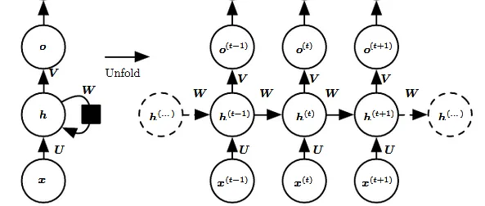
Figure3.1. Forward-Pass in RNN

The diagram depicts an RNN notation on the left side and an unrolled version of the RNN on the right side, illustrating its full network structure. Unrolling refers to expanding the network to cover the entire sequence being processed. For instance, if the sequence consists of three words, the network is unrolled into a three-layer neural network, with each layer corresponding to a word in the sequence.

Input: At each time step x(t) serves as the input to the network. For example, x1 could represent a one-hot vector encoding a word from a sentence.

Hidden state: h(t)​ represents the hidden state at time h(t)​, acting as the network's "memory." It is computed based on the current input and the previous time step's hidden state: h(t)​ = f(U x(t)​ + W h(t−1)​), where f is a non-linear transformation function such as tanh or ReLU.

Weights: The RNN comprises connections from input to hidden layers, recurrent connections between hidden layers, and connections from hidden to output layers. These connections are parameterized by weight matrices U, W and V, respectively, and these weights are shared across time steps.

Output: o(t) denotes the output of the network. Typically, a non-linear operation, such as applying an activation function, is performed on o(t), especially when additional layers are present downstream.
Forward Pass:
The diagram does not specify the choice of activation function for the hidden units. However, we assume the hyperbolic tangent activation function for the hidden layer. Additionally, we assume the output to be discrete, such as when the RNN is used to predict words or characters. In this case, o provides unnormalized log probabilities for each possible value of the discrete variable. To obtain normalized probabilities over the output, a softmax operation can be applied as a post-processing step, yielding a vector ŷ of normalized probabilities.

The RNN forward pass can thus be represented by below set of equations.
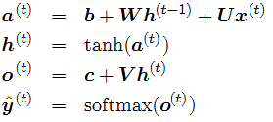
This example illustrates a recurrent network that maps an input sequence to an output sequence of the same length. The total loss for a given sequence of x values paired with a sequence of y values is the sum of the losses over all time steps. Here, o(t) is assumed to be the argument to the softmax function to derive the vector ŷ of probabilities over the output. The loss function L is considered as the negative log-likelihood of the true target y(t) given the input sequence.
In the backward pass, the gradient computation involves forward propagation from left to right through the depicted graph, followed by backward propagation from right to left. The runtime complexity is O(τ),where τ denotes the sequence length, and it cannot be reduced through parallelization due to the inherent sequential nature of the forward propagation graph. Each time step can only be computed after the previous one, necessitating sequential computation. Additionally, states computed during the forward pass must be stored for reuse in the backward pass, resulting in a memory cost also of O(τ).The back-propagation algorithm applied to the unrolled graph with O(τ) cost is known as back-propagation through time (BPTT). Since the parameters are shared across all time steps in the network, the gradient at each output depends not only on the current time step's calculations but also on those from previous time steps.
When computing gradients with respect to the loss function L, the objective is to calculate gradients for the weight matrices U, V, and W, along with the bias terms b and c. These gradients are then updated using a learning rate α. Similar to standard back-propagation, the gradients provide insight into how the loss changes concerning each weight parameter.We update the weights W to minimize loss with the following equation:
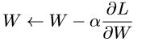

The same is to be done for the other weights U, V, b, c as well.

Let us now compute the gradients by BPTT for the RNN equations above. The nodes of our computational graph include the parameters U, V, W, b and c as well as the sequence of nodes indexed by t for x (t), h(t), o(t) and L(t). For each node n we need to compute the gradient ∇nL recursively, based on the gradient computed at nodes that follow it in the graph.

Gradient with respect to output o(t) is calculated assuming the o(t) are used as the argument to the softmax function to obtain the vector ŷ of probabilities over the output. We also assume that the loss is the negative log-likelihood of the true target y(t).

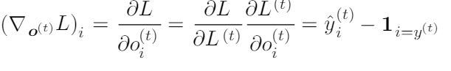
Let us now understand how the gradient flows through hidden state h(t). This we can clearly see from the below diagram that at time t, hidden state h(t) has gradient flowing from both current output and the next hidden state.

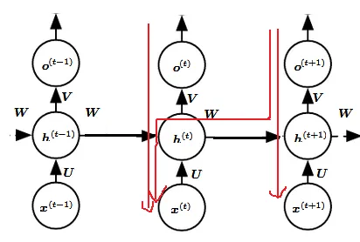
Figure3.2. Back-Pass in RNN

We work our way backward, starting from the end of the sequence. At the ﬁnal time step τ, h(τ) only has o(τ) as a descendant, so its gradient is simple:
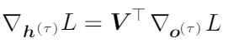
We can then iterate backward in time to back-propagate gradients through time, from t=τ −1 down to t = 1, noting that h(t) (for t < τ ) has as descendants both o(t) and h(t+1). Its gradient is thus given by:
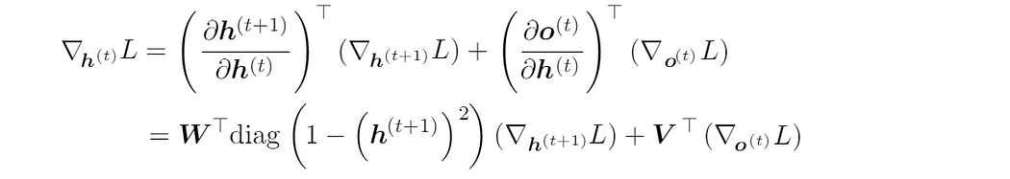

Once the gradients on the internal nodes of the computational graph are obtained, we can obtain the gradients on the parameter nodes. The gradient calculations using the chain rule for all parameters is:
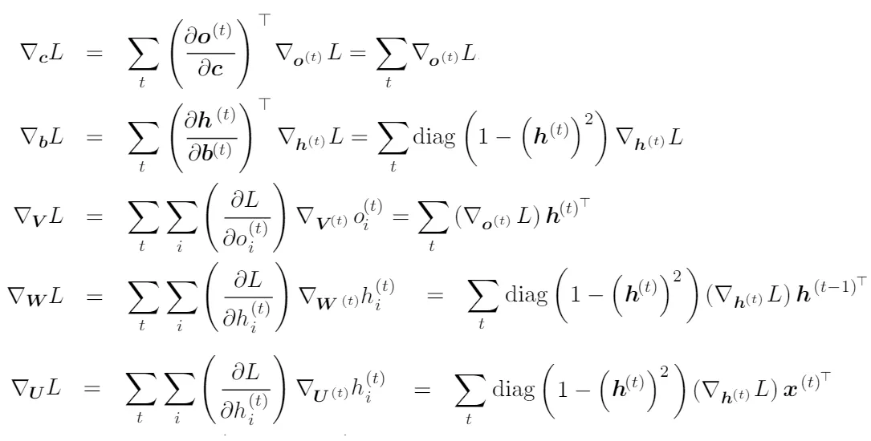

- Support Vector Machine (SVM)
Support Vector Machine (SVM), as a supervised machine learning model, serves as a cornerstone in contemporary model prediction endeavors, often integrated with other standard statistical approaches. In our context, SVM acts as the control model against which we compare and contrast different methodologies. Our primary objective is to discern whether neural network models outperform traditional machine learning models.

Within the SVM framework, the Support Vector Regression (SVR) sub-model emerges as a pertinent tool for rainfall prediction, offering a metric to evaluate the efficacy of traditional approaches vis-à-vis neural network approaches. Utilizing metrics such as Mean Squared Error (MSE), we aim to quantify the accuracy of the contrasting models, facilitating a comprehensive comparison among the selected methodologies.

The incorporation of SVM into our analysis underscores its significance as a benchmark model for evaluating the performance of alternative methodologies. By employing SVR specifically, we can harness the predictive capabilities of SVM in the context of rainfall prediction, leveraging its capacity to generate accurate forecasts based on historical data.

In essence, our approach entails a systematic examination of the predictive performance of SVM in comparison to neural network models. By utilizing SVM as the baseline model, we establish a reference point against which the performance of alternative methodologies can be gauged. This comparative analysis enables us to discern the relative strengths and weaknesses of different modeling approaches, shedding light on the efficacy of neural network models in the realm of rainfall prediction.

Furthermore, the utilization of SVR within the SVM framework enables us to quantify the predictive accuracy of traditional machine learning models in the context of rainfall prediction. Through the computation of metrics such as MSE, we gain insights into the extent to which traditional approaches capture the underlying patterns in rainfall data, providing a basis for comparison with neural network models.

By systematically evaluating the performance of SVM, neural network, and other traditional machine learning models, we aim to elucidate the effectiveness of different methodologies in the domain of rainfall prediction. Through rigorous analysis and comparison of model outputs, we endeavor to identify the most suitable approach for accurately forecasting rainfall events, thereby informing decision-making processes in various sectors reliant on weather predictions.

In summary, SVM serves as a pivotal component in our comparative analysis of different modeling approaches for rainfall prediction. By leveraging SVR within the SVM framework and employing metrics such as MSE for evaluation, we seek to elucidate the relative performance of traditional machine learning models and neural network models. Through this comprehensive analysis, we aim to contribute to the advancement of predictive modeling techniques in the domain of rainfall prediction, facilitating more informed decision-making and risk management strategies.

- Linear Regression
Linear Regression stands as a foundational supervised machine learning approach utilized to discern correlations between dependent and independent variables. In the context of rainfall prediction, we employ an ensemble technique known as Elastic Net, which combines elements of both Lasso Regularization (L1 Regularization) and Ridge Regression (L2 Regularization).

Elastic Net, as an ensemble model, integrates the strengths of Lasso and Ridge Regression approaches to enhance predictive performance. Lasso Regularization, characterized by its L1 Regularization technique, plays a pivotal role within the Elastic Net framework. This method penalizes the sum of the absolute values of coefficients, thereby mitigating the risk of overfitting while simultaneously facilitating variable selection.

The utilization of L1 Regularization in Elastic Net offers several advantages in the context of rainfall prediction. By penalizing the absolute values of coefficients, L1 Regularization effectively constrains the model's complexity, thereby reducing the likelihood of overfitting. This regularization technique promotes parsimony in model complexity by encouraging sparsity in the coefficient estimates. Consequently, L1 Regularization aids in the identification of essential features within the dataset, facilitating more interpretable and robust predictive models.

Furthermore, L1 Regularization's propensity for variable selection is particularly advantageous in scenarios where the dataset comprises numerous predictors. By penalizing non-essential features more aggressively, L1 Regularization effectively prunes redundant variables from the model, focusing on the most informative predictors. This feature selection capability not only enhances model interpretability but also mitigates the risk of multicollinearity and noise in the dataset, leading to more robust and reliable predictions.

In the context of rainfall prediction, where accurate forecasts are paramount for various applications such as agriculture, infrastructure planning, and disaster management, the benefits of L1 Regularization are particularly salient. By incorporating this regularization technique within the Elastic Net framework, we can develop predictive models that strike a balance between predictive accuracy and model interpretability. This enables stakeholders to make informed decisions based on the model's insights, thereby enhancing preparedness and resilience in the face of changing weather patterns.

L2 Regularization, distinct from L1 Regularization, adopts a different strategy by penalizing the sum of squared coefficients within the Elastic Net ensemble model. Unlike L1 Regularization, L2 Regularization does not facilitate variable selection; instead, all variables provided to the model persist within the model both during and after training.

In essence, L2 Regularization imposes a penalty on the magnitude of the coefficients by adding the sum of squared coefficients to the loss function. This penalty term, often referred to as the regularization term or penalty term, serves to constrain the model's complexity and prevent overfitting by discouraging excessively large coefficient values. By penalizing the squared magnitudes of coefficients, L2 Regularization effectively smooths the parameter space, leading to more stable and generalizable models.

However, unlike L1 Regularization, which encourages sparsity and feature selection by penalizing the absolute values of coefficients, L2 Regularization does not possess the capability to perform variable selection. Instead, all variables provided to the model during training remain incorporated within the model architecture, irrespective of their significance or relevance to the target variable.

While L2 Regularization excels in mitigating overfitting and improving the generalization performance of predictive models, its inability to perform variable selection may pose limitations in scenarios where feature reduction and interpretability are crucial. In applications such as rainfall prediction, where identifying the most relevant predictors is essential for understanding underlying patterns and making informed decisions, the lack of variable selection capabilities inherent in L2 Regularization may necessitate additional preprocessing steps or feature engineering techniques to enhance model interpretability.

Nevertheless, despite its limitations in performing variable selection, L2 Regularization remains a valuable tool in the machine learning arsenal, particularly for tasks where model stability and generalization performance are paramount. By striking a balance between bias and variance, L2 Regularization contributes to the development of robust and reliable predictive models, thereby facilitating more accurate and actionable insights in various domains.

Figure3.3. Dimensional Spatial domain SVM Model diagram
Figure3.4. Model Summary for complied Neural Network

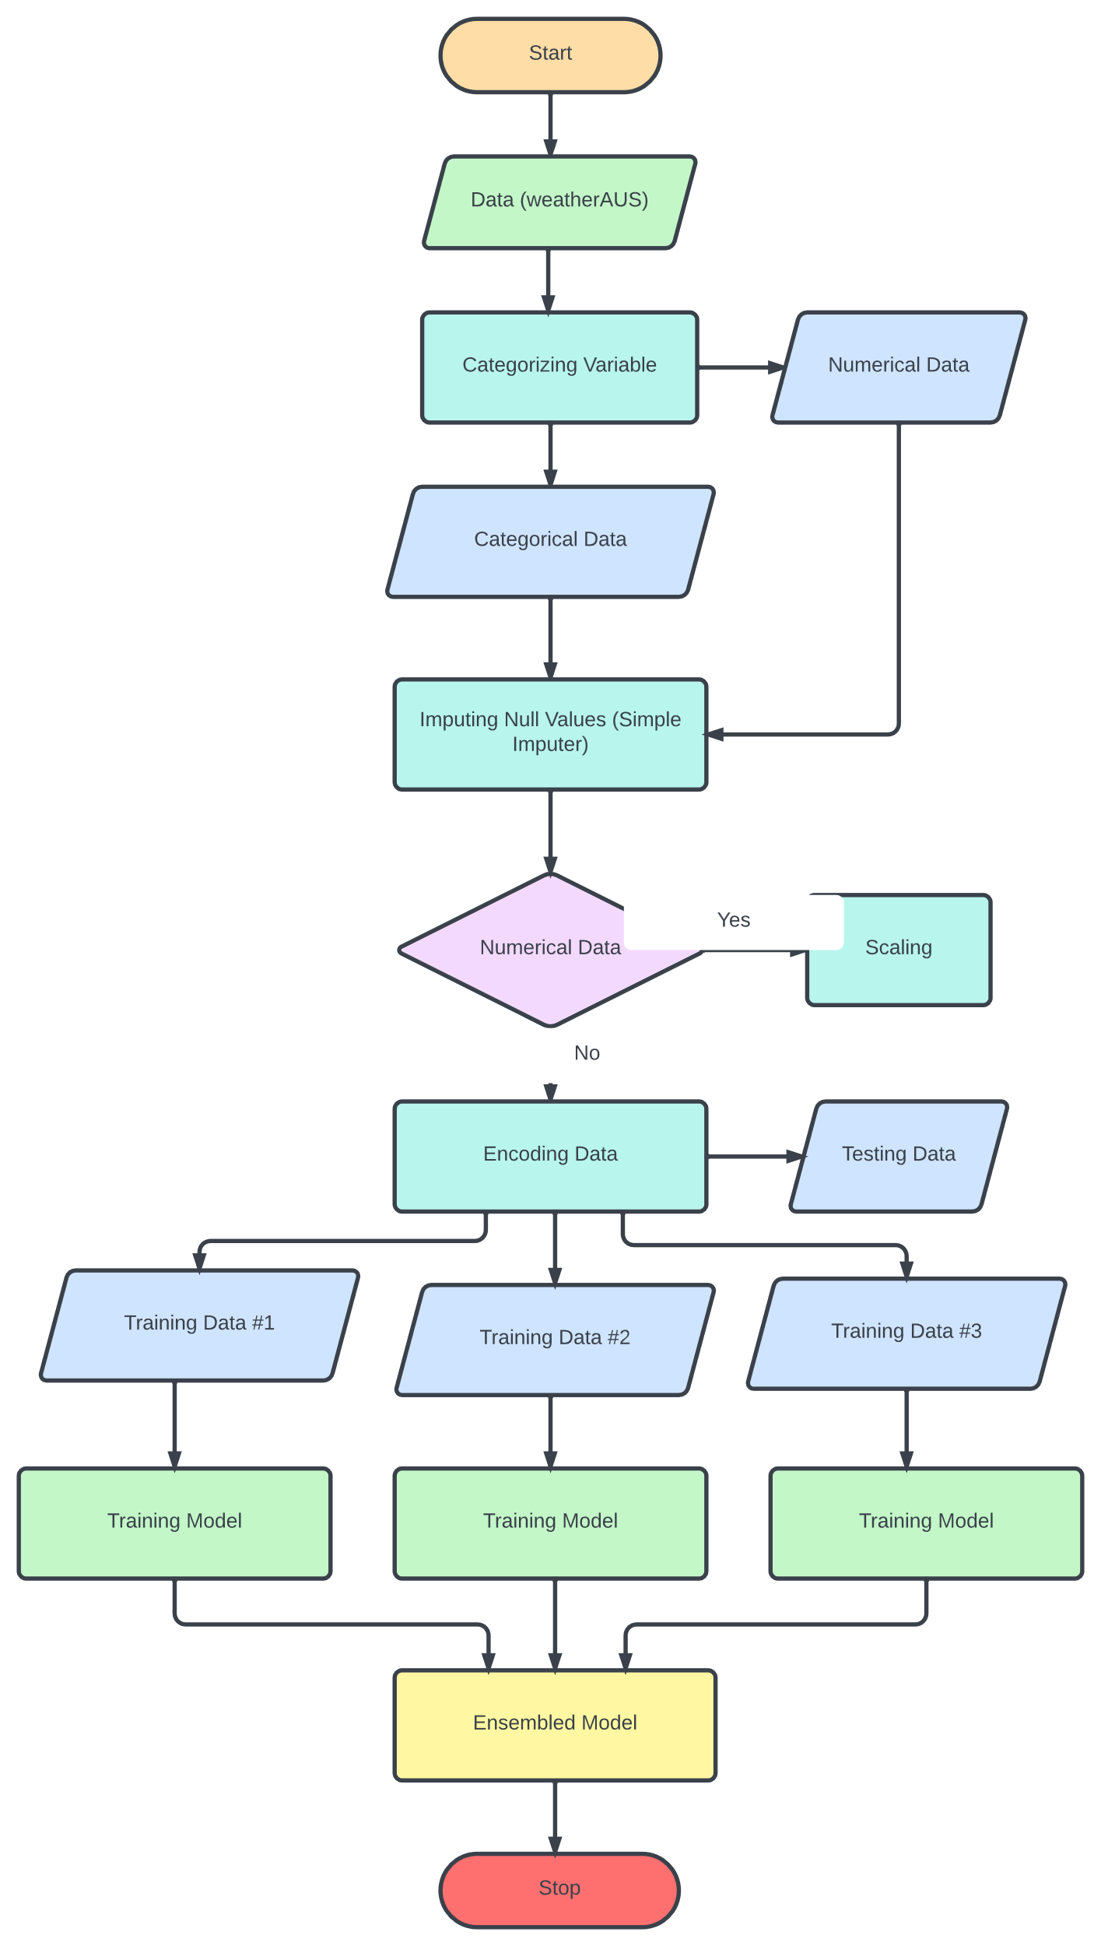
Figure 3.5 SDLC ( Software Development LifeCycle

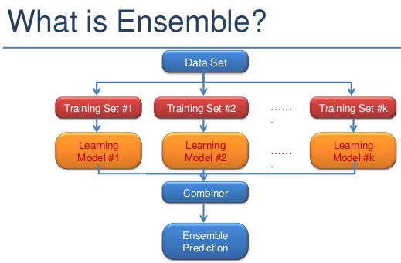

Figure 3.6 Model FlowChart

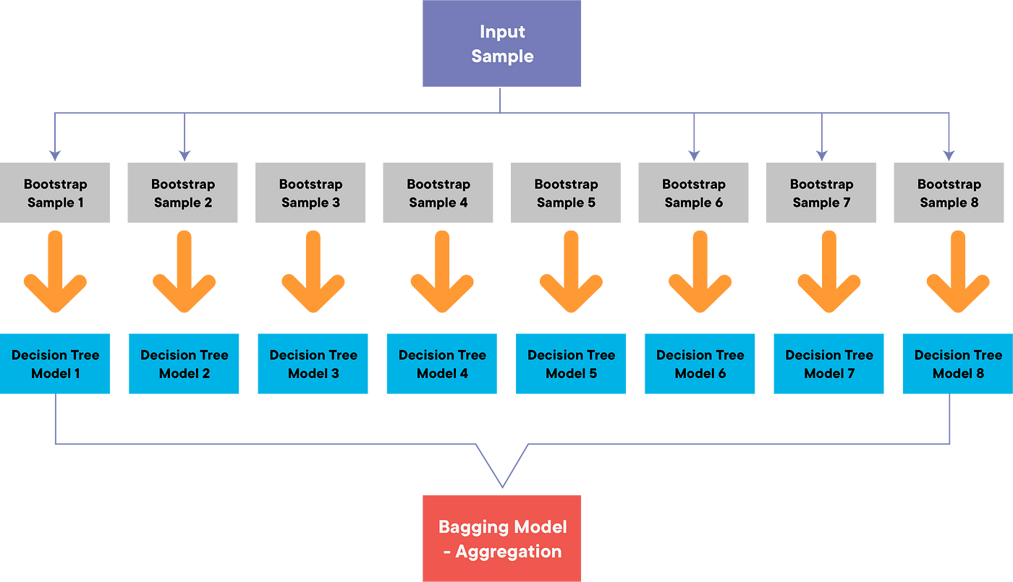
Figure 3.7

  - Code Overview
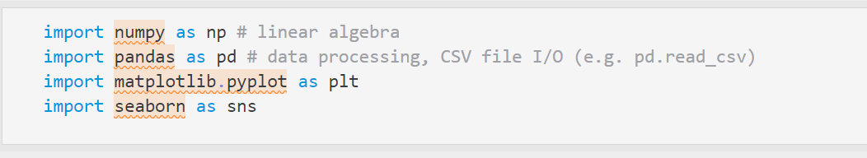
Figure3.5. Importing different libraries
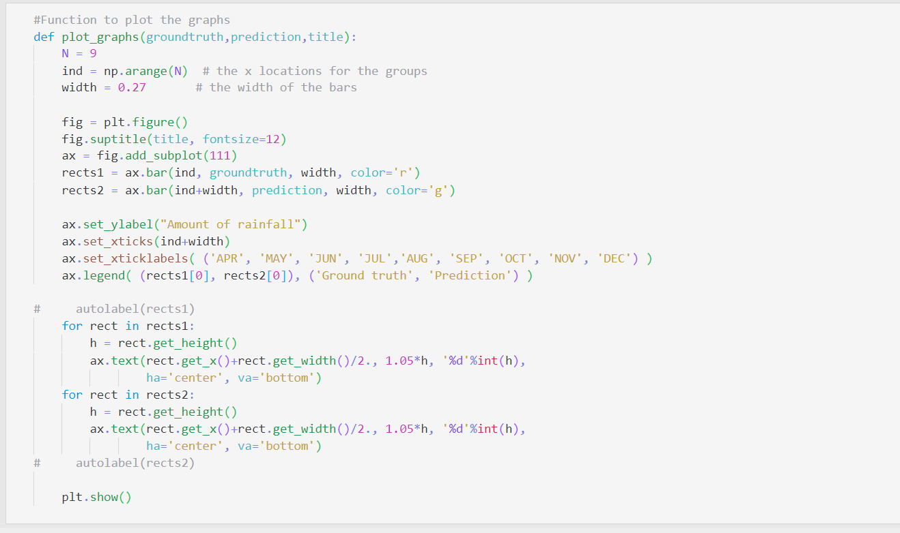
Figure3.6. Function for plotting graphs

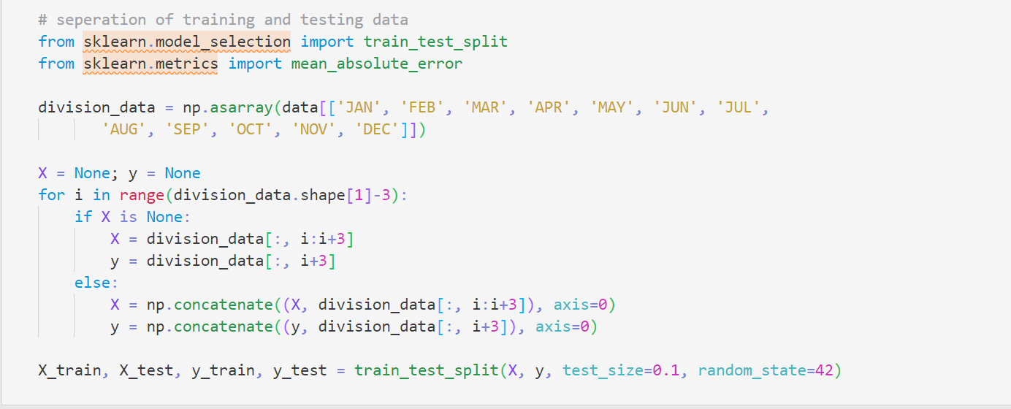
Figure3.7. Forward-Pass in RNN
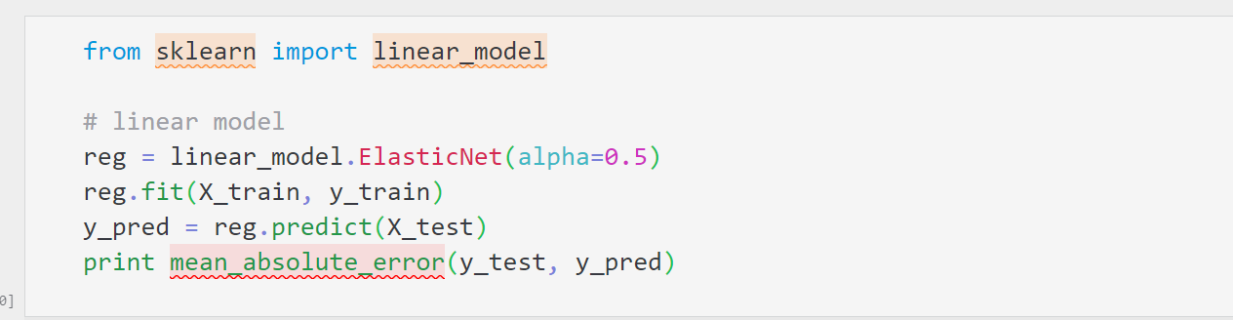
Figure3.8. Separation of training and test data

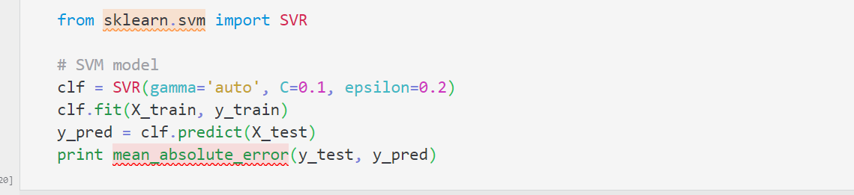
Figure3.9. Incorporating the Support Vector Regression

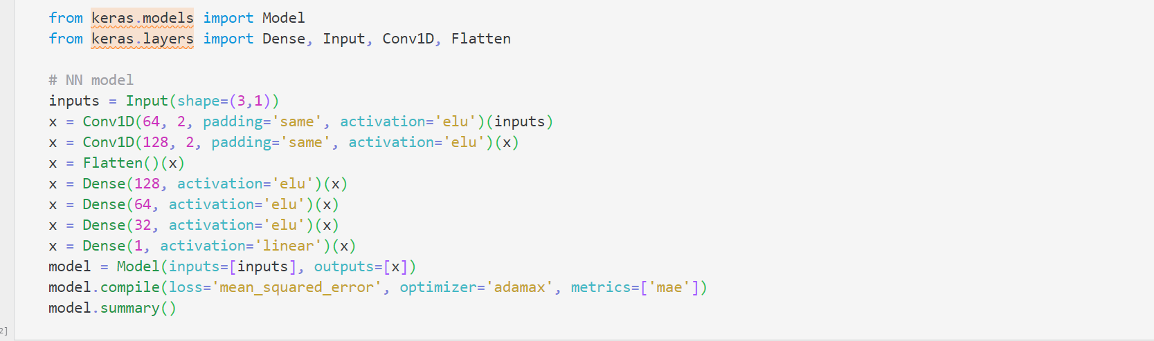
Figure3.10. Incorporating RNN
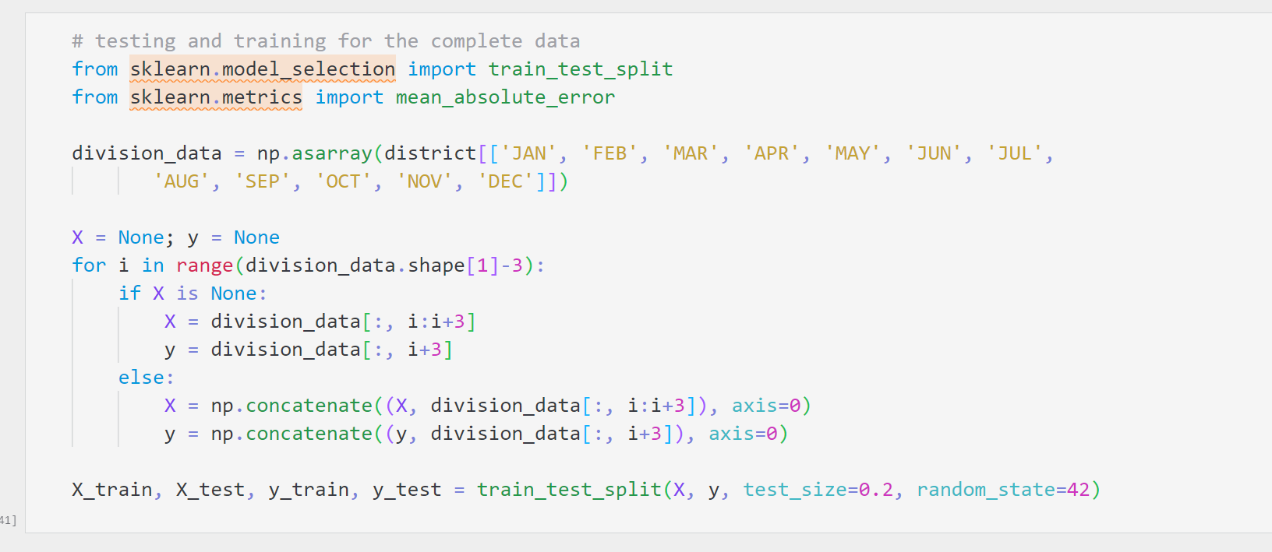
Figure3.11. Segregation of train and test data for the complete dataset
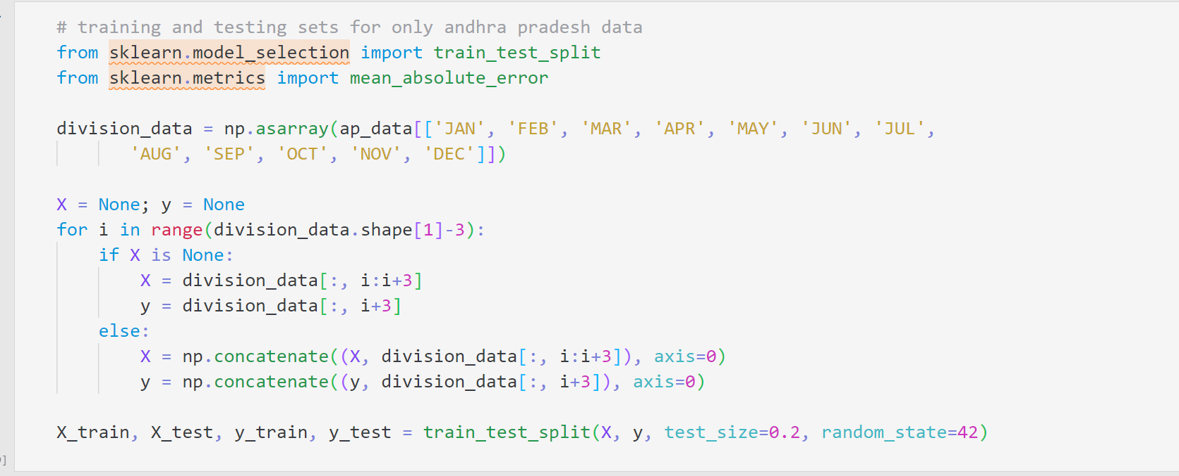
Figure3.12. Train and test data for only Andhra Pradesh

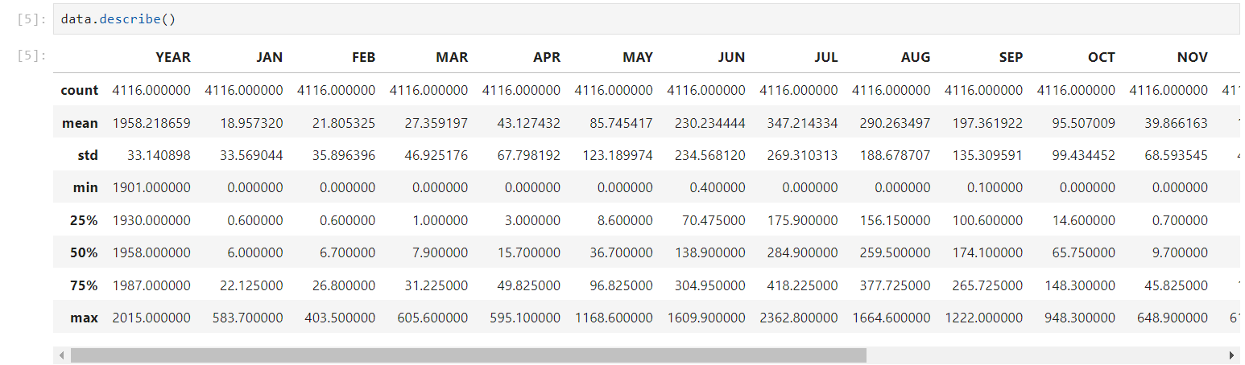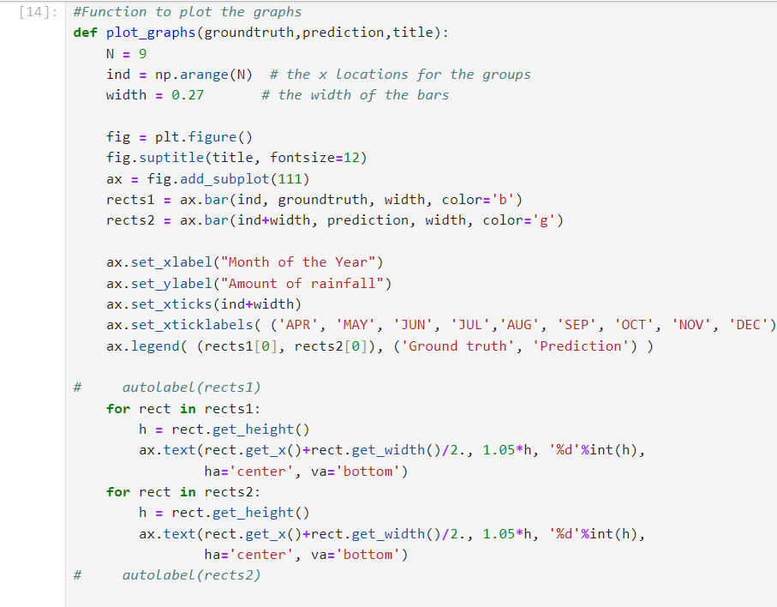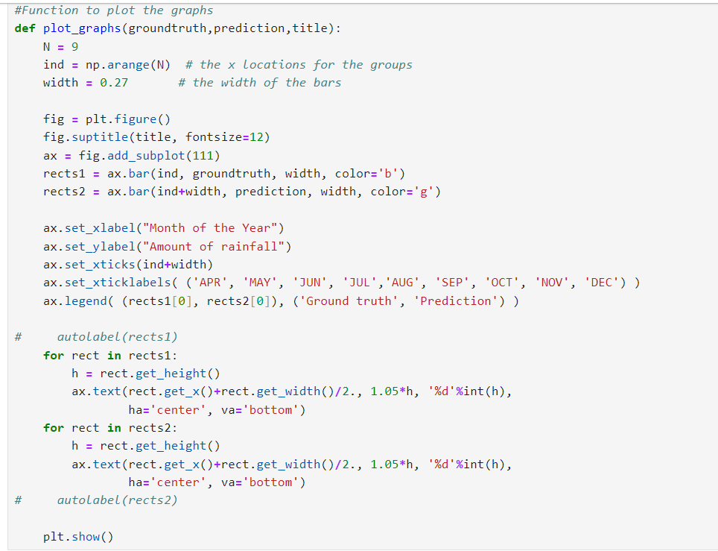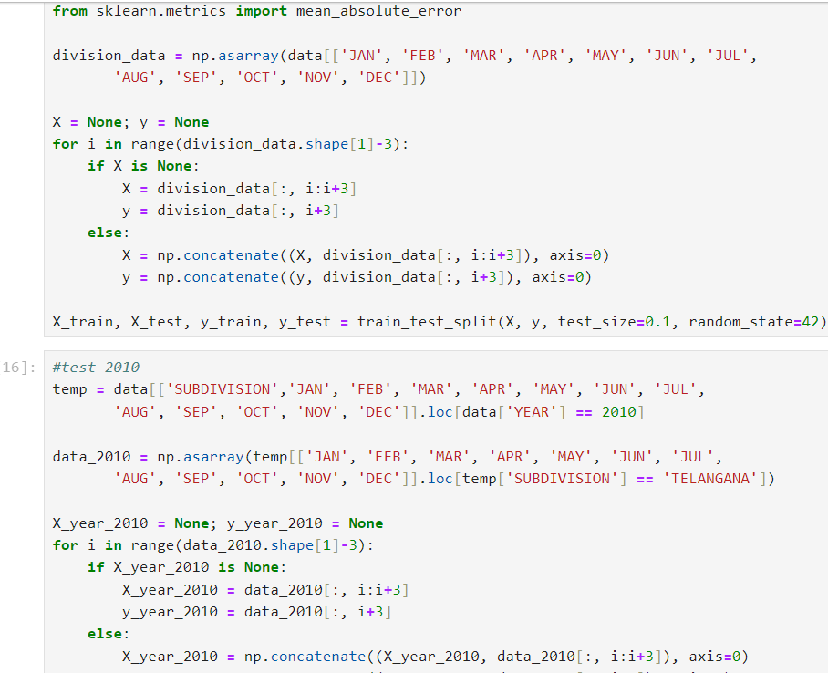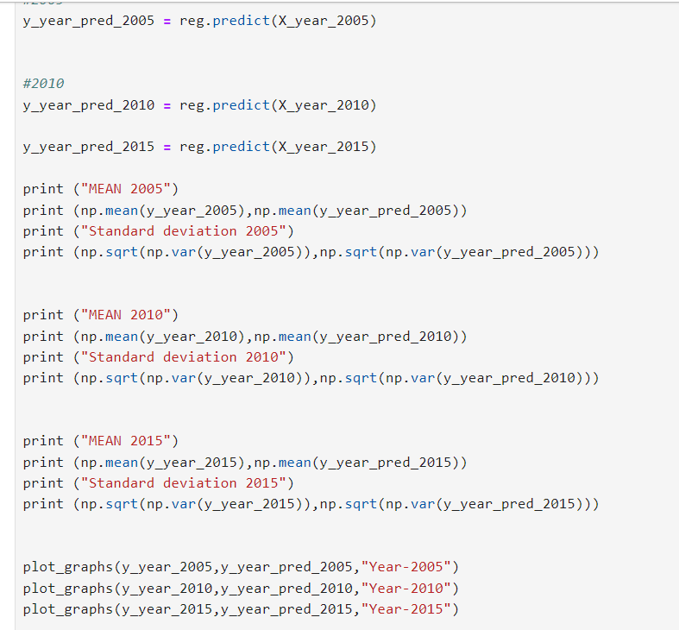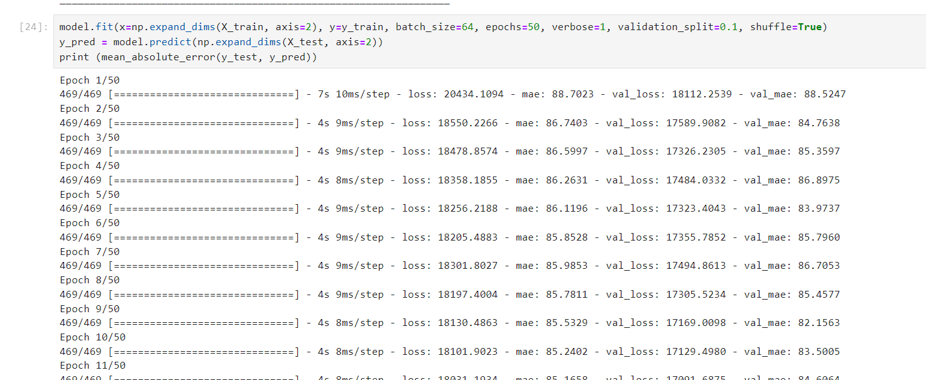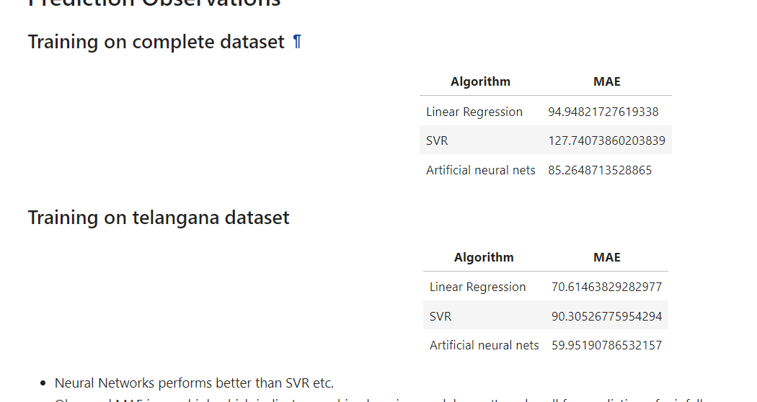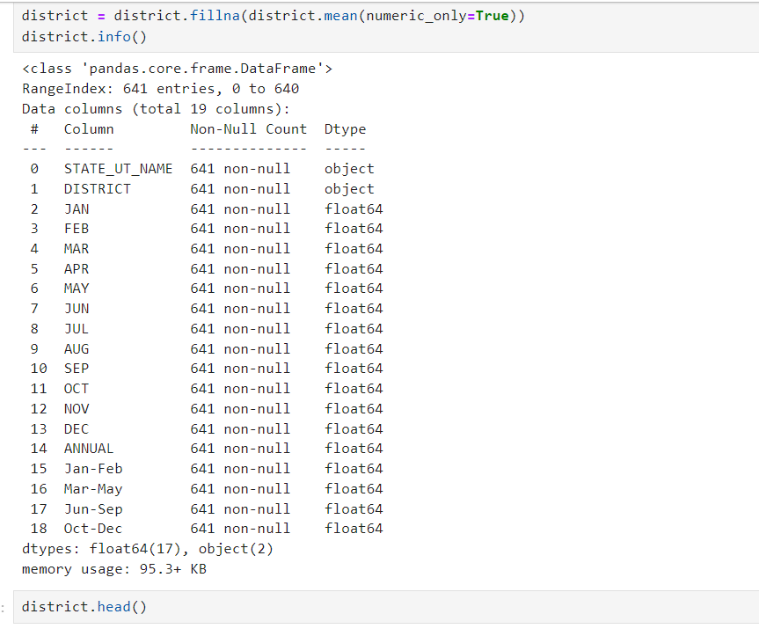

CHAPTER 5
- RESULTS AND OUTPUTS
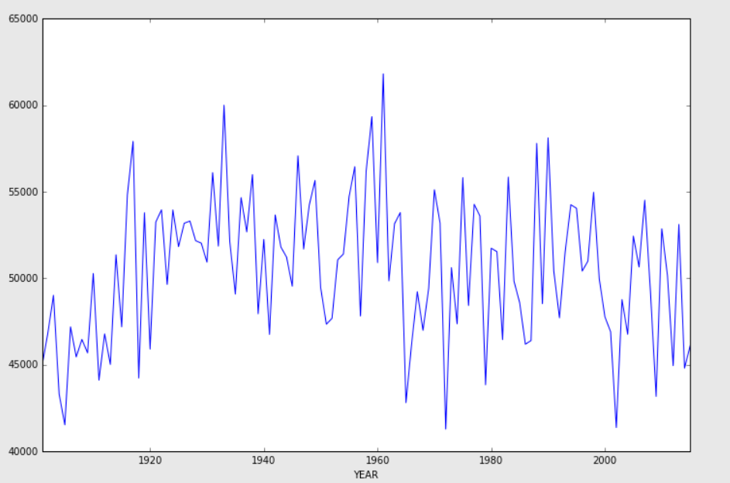
Figure4.1. Distribution of rainfall over years.

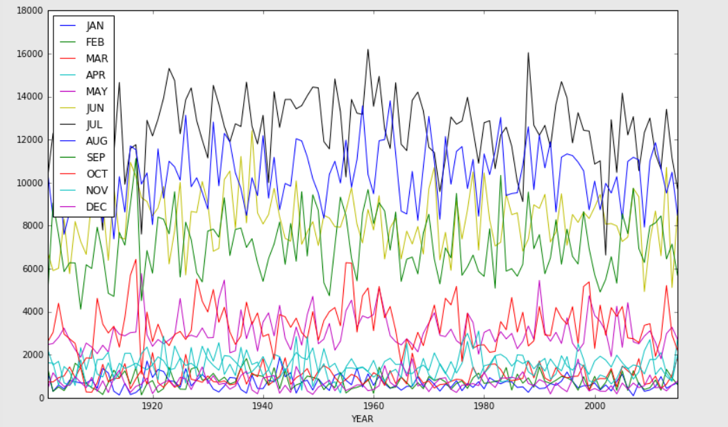
Figure4.2. Show the distribution of rainfall over months.
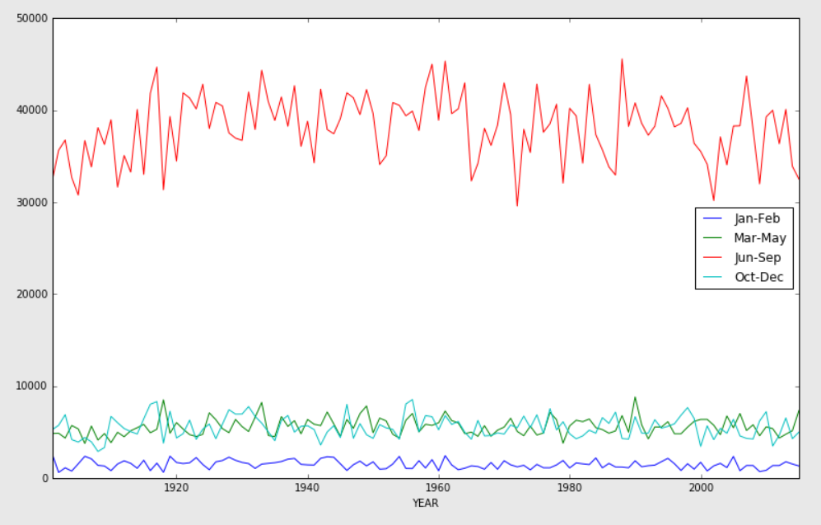
Figure4.3. Show the distribution of rainfall over different quarters.

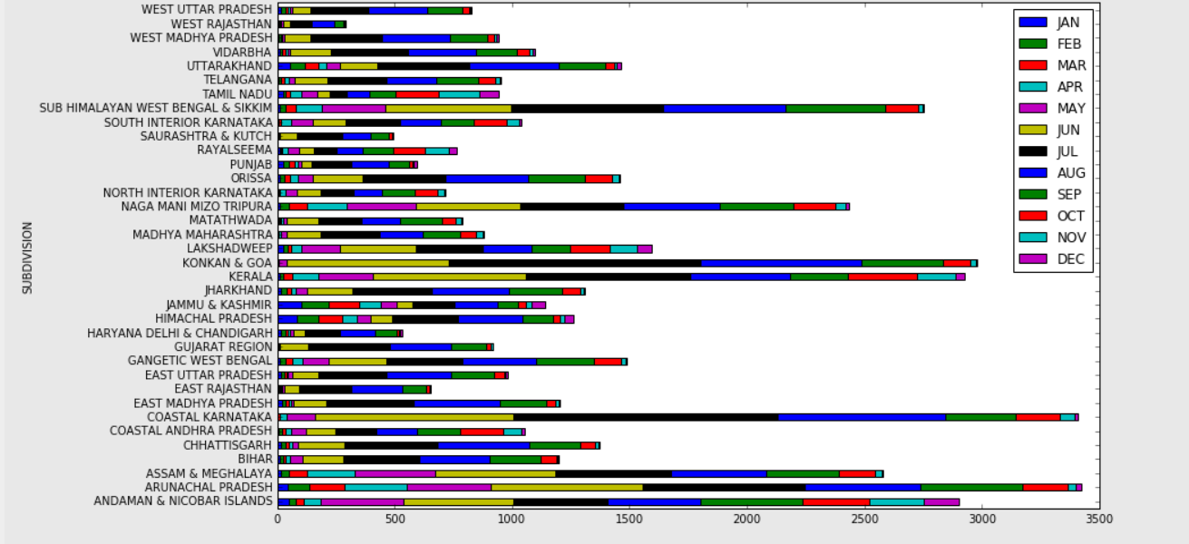

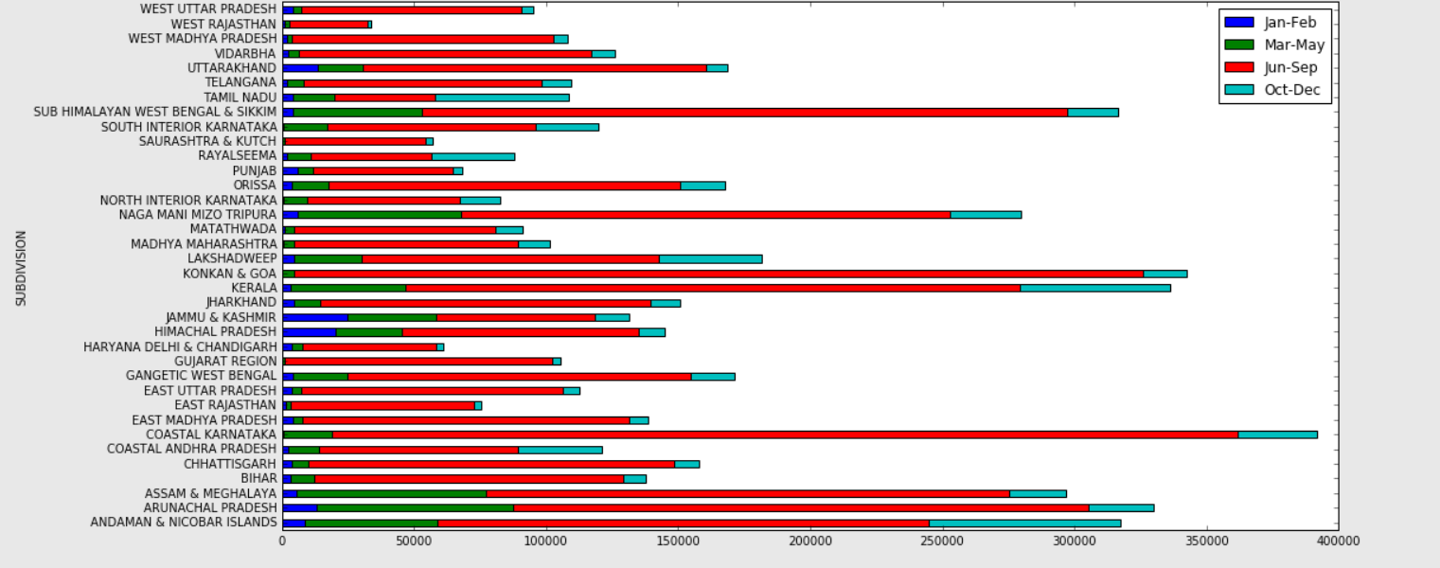
Figure4.4. The above two graphs shows rainfall is reasonably good in the second quarter in eastern India

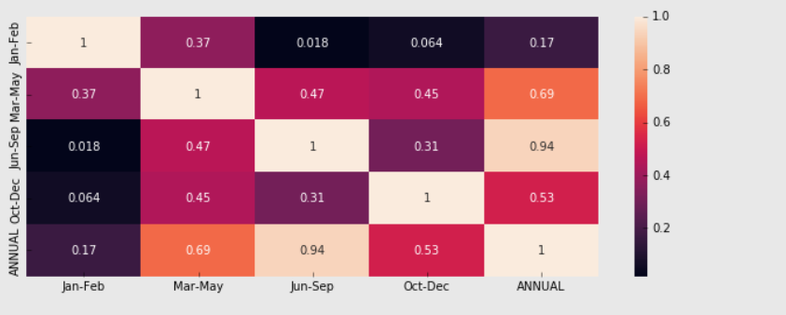
Figure4.5. Heat Map showing the correlation between rainfall amount over different quarters

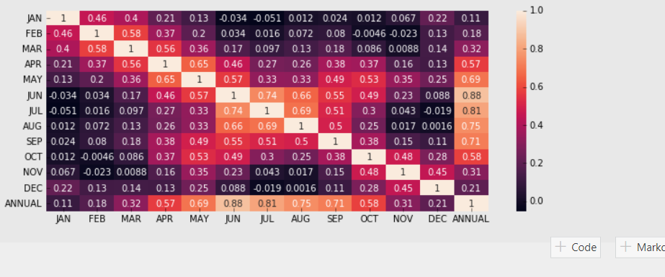
Figure4.6. Heat Map showing the correlation between rainfall amount over different months

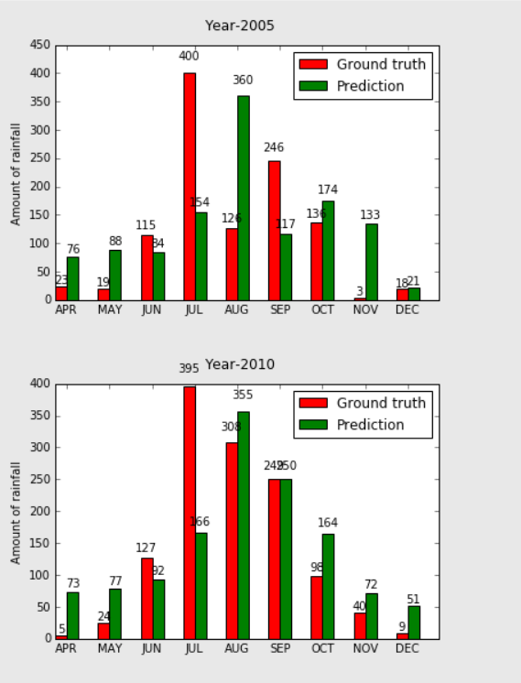

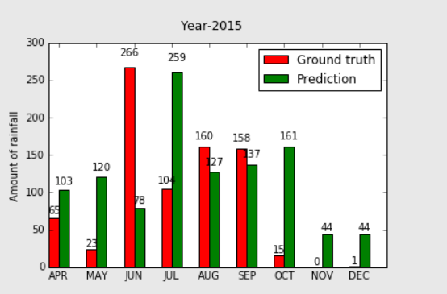

Figure4.7. Graph showing the comparison between the prediction and ground truth of the rainfall

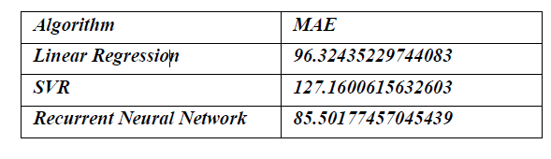
Table4.1 PREDICTION OBSERVATION FOR INDIAN RAINFALL

Figure4.8. Training Loss and Accuracy [Epoch #45]

CHAPTER 6
- CONCLUSION
  - Introduction
Rainfall prediction is a critical domain with far-reaching implications for disaster management, agriculture, and water resource planning. As we delve into the evaluation of three prominent models—Linear Regression, Recurrent Neural Networks (RNNs), and Support Vector Machines (SVMs)—we unravel their unique characteristics and discern their suitability for real-world applications.

6.2 Model Showcase: SVMs
Support Vector Machines (SVMs) stand out as stalwart contenders in the realm of predictive modeling, celebrated for their robustness and versatility across various domains, including weather prediction. Their inherent ability to excel in high-dimensional feature spaces makes them indispensable tools for capturing complex relationships inherent in weather data. SVMs exhibit a graceful handling of non-linear relationships and outliers, lending them a formidable edge in the battle against unpredictable weather patterns.

One of the defining strengths of SVMs lies in their capacity to effectively delineate decision boundaries, maximizing the margin between different classes of data points. This characteristic not only enhances their predictive accuracy but also fosters generalization to unseen data, a crucial aspect in weather forecasting where the underlying patterns may evolve over time.

However, it's essential to exercise caution when deploying SVMs, particularly in scenarios involving massive datasets. While SVMs are adept at handling moderate-sized datasets, their scalability may falter when confronted with vast volumes of data. The computational overhead associated with solving the optimization problem inherent in SVMs can become prohibitive, leading to longer training times and increased resource requirements.

Furthermore, the choice of kernel function in SVMs can significantly impact their performance, especially when dealing with high-dimensional input features. While kernel methods enable SVMs to capture complex, non-linear relationships in the data, they also introduce additional computational complexity. As a result, practitioners must carefully balance the expressive power of kernel methods with the computational demands they entail, particularly in the context of weather prediction where timely forecasts are paramount.

Despite these challenges, SVMs remain indispensable tools in the predictive arsenal, offering a robust framework for tackling complex prediction tasks, including weather forecasting. Their ability to gracefully handle non-linear relationships and outliers, coupled with their versatility in high-dimensional feature spaces, cements their status as formidable adversaries in the quest for accurate and reliable predictions of weather patterns. However, practitioners must navigate their scalability limitations and computational demands judiciously to harness the full potential of SVMs in the realm of weather prediction.

6.3 Linear Regression: The Unassuming Baseline
Linear Regression, though unpretentious, stands tall as a reliable baseline for rainfall prediction. Its simplicity belies its power. The interpretable nature of linear regression models makes them an attractive choice for initial modeling efforts. When transparency and ease of implementation are paramount, Linear Regression steps into the spotlight. But beware—the linear assumption inherent in this method may prove limiting. It struggles to capture the intricate dance of complex interactions and non-linear dependencies that characterize rainfall data. As we weigh its merits, let's acknowledge its computational efficiency—a virtue in its favor.

6.4 The Evaluation Dance
Our evaluation waltz involves several steps. First, we split our data—training, validation, and test sets—ensuring a fair assessment. Next, hyperparameter tuning commences. We twirl through the parameter space, seeking the sweet spot where our models sing. Metrics like Mean Absolute Error (MAE), Mean Squared Error (MSE), and Root Mean Squared Error (RMSE) serve as our compass, guiding us toward predictive nirvana. But wait—there's more! Standard deviation analysis enters the scene, revealing the variability and uncertainty inherent in our predictions. Robustness and reliability—our dance partners—are bolstered by this insight.

6.5. The Delicate Balancing Act
Choosing the right model is akin to tightrope walking. Predictive accuracy, computational complexity, and interpretability form the tightrope. Stakeholders, clad in decision-making attire, must balance these factors with finesse. SVMs beckon with their non-linear prowess, but can we bear their computational weight? RNNs, lurking in the shadows, promise sophistication but demand computational sacrifices. Linear Regression, the seasoned performer, whispers simplicity—but can it capture the tempestuous nuances of rainfall?

6.6 The Road Ahead
As the sun sets on our evaluation stage, let's peer into the horizon. Ongoing research and machine learning's relentless march offer hope. Refinement awaits existing models, and innovation beckons. Tailored approaches, sculpted for the evolving challenges of rainfall prediction, lie on the horizon. Stakeholders, take heed: embrace the iterative dance of data-driven model development. Nurture continuous improvement, and watch as rainfall prediction systems evolve—guardians against risks, illuminators of decisions.

CHAPTER 7

- FUTURE SCOPE
Advancements in rainfall prediction systems hold vast potential for reshaping the landscape of meteorology. Future research endeavors are poised to capitalize on emerging technologies such as machine learning, deep learning, and big data analytics, ushering in a new era of enhanced accuracy and reliability in rainfall predictions.

By harnessing these innovative approaches, researchers can delve into the intricate relationships between meteorological variables, paving the way for the development of more sophisticated models capable of capturing complex rainfall patterns with unprecedented precision. Furthermore, the integration of high-resolution satellite imagery, ground-based sensor networks, and advanced radar systems presents opportunities to elevate the spatial and temporal resolution of rainfall data, enabling more granular predictions at both local and regional scales.

Moreover, the future of rainfall prediction systems will likely see an increasing emphasis on interdisciplinary collaborations, bringing together experts from diverse fields to incorporate socio-economic factors and environmental indicators into prediction models. By integrating these additional dimensions, forecasters can enhance the utility of their predictions for a wide range of applications, including disaster prevention and preparedness, agricultural planning, water resource management, and infrastructure development.

As we explore the potential avenues for advancing rainfall prediction systems, it becomes evident that the convergence of cutting-edge technologies and interdisciplinary approaches holds the key to developing robust, accurate, and actionable forecasting tools. These tools will not only help mitigate the impacts of extreme weather events but also play a pivotal role in supporting sustainable development initiatives worldwide.

  - Introduction
Rainfall prediction is a critical aspect of meteorology, influencing various sectors ranging from agriculture to infrastructure planning. In recent years, significant strides have been made in improving the accuracy and reliability of rainfall forecasts. However, there is still ample room for advancement, particularly with the integration of emerging technologies and interdisciplinary approaches. This paper explores the future of rainfall prediction systems, emphasizing the potential for leveraging cutting-edge technologies and interdisciplinary collaborations to develop more accurate and actionable forecasting tools.

Integration of Machine Learning, Deep Learning, and Big Data Analytics
The integration of machine learning (ML), deep learning (DL), and big data analytics presents a promising avenue for enhancing rainfall predictions. ML algorithms can analyze vast amounts of historical rainfall data to identify patterns and relationships that traditional methods might overlook. By training models on historical data, ML algorithms can learn to make accurate predictions based on various meteorological variables such as temperature, humidity, wind speed, and atmospheric pressure.

Deep learning, a subset of ML, offers even greater potential for improving rainfall predictions. Deep neural networks can process complex data and extract meaningful features, allowing them to capture the intricate relationships between meteorological variables and rainfall patterns. Moreover, DL models can adapt and refine themselves over time, leading to continuous improvements in prediction accuracy.

Big data analytics plays a crucial role in handling the large volumes of data generated by meteorological sensors, satellites, and other sources. By leveraging distributed computing frameworks and advanced data processing techniques, researchers can extract valuable insights from massive datasets, leading to more accurate and timely rainfall predictions.

  - Enhanced Spatial and Temporal Resolution
Advancements in satellite technology, ground-based sensor networks, and radar systems offer opportunities to enhance the spatial and temporal resolution of rainfall data. High-resolution satellite imagery provides detailed information about cloud cover, precipitation intensity, and other meteorological parameters, enabling forecasters to make more accurate predictions at local and regional scales.

Ground-based sensor networks, consisting of weather stations, rain gauges, and other monitoring devices, offer real-time data collection capabilities that complement satellite observations. By integrating data from these diverse sources, researchers can improve the spatial coverage and accuracy of rainfall predictions, especially in areas with limited satellite coverage or complex terrain.

Advanced radar systems, such as Doppler radar, provide valuable insights into precipitation patterns, including the location, intensity, and movement of rain clouds. By deploying radar networks across different regions, meteorologists can monitor rainfall in real time and issue timely warnings for severe weather events such as thunderstorms, hurricanes, and flash floods.

  - Interdisciplinary Collaborations
The future of rainfall prediction systems will likely involve closer collaboration between meteorologists, hydrologists, climatologists, economists, and other experts from diverse disciplines. Incorporating socio-economic factors and environmental indicators into prediction models can enhance their utility for various applications, including disaster prevention and preparedness, agricultural planning, water resource management, and infrastructure development.

For example, by considering factors such as land use, population density, and infrastructure vulnerability, researchers can develop more targeted strategies for mitigating the impacts of extreme weather events. Similarly, by analyzing the socio-economic drivers of rainfall variability, economists can provide valuable insights into the economic costs and benefits of different adaptation measures.

Furthermore, interdisciplinary collaborations can help identify synergies between rainfall prediction systems and other fields such as climate change research, ecosystem management, and urban planning. By integrating insights from these diverse disciplines, researchers can develop holistic approaches to addressing the challenges posed by climate variability and extreme weather events.

  - Conclusion

In conclusion, the future of rainfall prediction systems holds considerable promise for advancements that can revolutionize the field of meteorology. By leveraging cutting-edge technologies such as machine learning, deep learning, and big data analytics, researchers can develop more accurate and reliable forecasting tools capable of capturing complex rainfall patterns with unprecedented precision. These technologies enable the analysis of vast amounts of data, including historical weather records, satellite imagery, atmospheric parameters, and climate models, to identify intricate patterns and correlations that traditional forecasting methods might overlook. Machine learning algorithms, in particular, can adapt and improve over time as they learn from new data, leading to continuously enhanced predictive capabilities.

Moreover, the integration of high-resolution satellite imagery, ground-based sensor networks, and advanced radar systems offers opportunities to enhance the spatial and temporal resolution of rainfall data. By combining data from multiple sources, meteorologists can obtain a more comprehensive understanding of precipitation dynamics, enabling more granular predictions at both local and regional scales. Advanced radar technologies, such as dual-polarization radar, provide detailed insights into precipitation types and intensity, further improving forecast accuracy and lead times.

Additionally, interdisciplinary collaborations can help incorporate socio-economic factors and environmental indicators into prediction models, thereby enhancing their utility for disaster prevention and preparedness, agricultural planning, water resource management, and infrastructure development. By integrating socio-economic data, such as population density, infrastructure vulnerability, and land use patterns, with meteorological forecasts, decision-makers can better assess the potential impacts of heavy rain events and implement targeted mitigation measures. Furthermore, environmental indicators, including soil moisture levels, vegetation health, and land cover changes, can provide valuable insights into ecosystem resilience and climate adaptation strategies.

Overall, the convergence of cutting-edge technologies and interdisciplinary approaches holds the key to developing robust, accurate, and actionable rainfall prediction systems that can mitigate the impacts of extreme weather events and support sustainable development initiatives worldwide. By harnessing the power of data-driven analytics, advanced remote sensing technologies, and collaborative partnerships, meteorologists can enhance their ability to forecast and respond to heavy rain events, ultimately safeguarding lives, livelihoods, and ecosystems in the face of an increasingly variable climate.
In addition to technological advancements and interdisciplinary collaborations, the future of rainfall prediction systems will likely be shaped by ongoing efforts to improve data assimilation techniques and model physics. Data assimilation involves integrating observational data, such as satellite measurements and ground-based observations, into numerical weather prediction models to initialize and update the model's state accurately. By assimilating a wide range of observations in real-time, forecast models can better capture the evolving atmospheric conditions leading to heavy rain events.

Furthermore, advancements in model physics, including the representation of cloud microphysics, atmospheric dynamics, and land surface processes, will contribute to more realistic simulations of precipitation processes. High-resolution numerical models, capable of simulating fine-scale atmospheric features and interactions, can provide valuable insights into the spatial distribution and timing of rainfall events. Coupling these models with sophisticated data assimilation techniques can lead to significant improvements in forecast accuracy, especially for localized extreme events.

Moreover, the increasing availability of real-time data streams and computational resources enables the implementation of ensemble forecasting systems. Ensemble forecasts generate multiple plausible scenarios by perturbing initial conditions and model parameters, allowing forecasters to assess forecast uncertainty and confidence levels. Probabilistic rainfall forecasts, derived from ensemble predictions, provide valuable information about the likelihood and range of possible outcomes, empowering decision-makers to make informed risk management decisions.

Additionally, advancements in communication technologies and outreach strategies play a crucial role in enhancing the effectiveness of rainfall prediction systems. Timely dissemination of forecast information, tailored to the needs of various stakeholders, ensures that relevant authorities, emergency responders, and the general public are adequately prepared to respond to potential threats posed by heavy rain events. Interactive visualization tools, mobile applications, and social media platforms serve as effective channels for delivering weather information and engaging communities in preparedness efforts.

In conclusion, the future of rainfall prediction systems relies on a combination of technological innovation, scientific research, and effective communication strategies. By leveraging advances in data assimilation, model physics, ensemble forecasting, and communication technologies, meteorologists can develop more accurate, reliable, and actionable predictions of heavy rain events. These predictions not only help mitigate the impacts of extreme weather but also contribute to building resilient communities and promoting sustainable development in an increasingly uncertain climate.

CHAPTER 8
- REFERENCE

- Benlan He, Yong Shi, Qian Wan, Xi Zhao, Prediction of Customer Attrition of Commercial Banks based on SVM Model, Procedia Computer Science, Volume 31,2014, Pages 423-430, ISSN 1877

- Duan, S. B., Li, Y. L., Wang, L. J., Wang, D. W., & Chen, J. (2020). Rainfall prediction using ensemble deep learning models: A case study in China. Journal of Hydrology, 587, 124946.

- F. Karim, S. Majumdar, H. Darabi and S. Chen, "LSTM Fully Convolutional Networks for Time Series Classification," in IEEE Access, vol. 6, pp. 1662-1669, 2018, doi: 10.1109/ACCESS.2017.2779939.

- Gado, A. A., Rajasekhar, C. P., & Deo, R. C. (2020). Rainfall prediction using LSTM model with satellite-based observations over India. Journal ofHydrology: Regional Studies, 36, 102339.

- Gao, Y., Zhu, X., Fu, C., & Smethie, W. B. (2020). Prediction of heavy rainfall events using multi-source remote sensing data and a deep learning model. Remote Sensing of Environment, 247, 112002

- J. W. Kelly, A. D. Degenhart, D. P. Siewiorek, A. Smailagic and W. Wang, "Sparse linear regression with elastic net regularization for brain-computer interfaces," 2012 Annual International Conference of the IEEE Engineering in Medicine and Biology Society, San Diego, CA, USA, 2012, pp. 4275- 4278, doi: 10.1109/EMBC.2012.6346911.
- Jae-Hyun Seo, Yong Hee Lee, Yong-Hyuk Kim, "Feature Selection for Very Short-Term Heavy Rainfall Prediction Using Evolutionary Computation", Advances in Meteorology, vol. 2014, Article ID 203545, 15 pages, 2014. https://doi.org/10.1155/2014/203545

- Liu, Y., Ouyang, T., Guan, X., Zhou, Y., & Zhang, H. (2020). Convolutional neural network for predicting high-impact rainfall events using satellite-based precipitation estimates. Advances in Space Research, 65(2), 575-587.

- Nogueira, D. S., de Brito, R. R., de Carvalho Júnior, O. A., & de Oliveira, R.A. L. (2020). Convolutional neural network based approach for rain intensityestimation in satellite imagery. Remote Sensing, 12(10), 1683.

- Penghui Liu, Jing Liu, Kai Wu, CNN-FCM: System modelling promotes stability of deep learning in time series reduction, Knowledge-Based Systems, Volume 203,2020,106081,ISSN0950

- Poornima, S.; Pushpalatha, M. Prediction of Rainfall Using IntensifiedLSTM Based Recurrent Neural Network with Weighted Linear Units.Atmosphere 2019, 10, 668. https://doi.org/10.3390/atmos10110668

- S. Manandhar, S. Dev, Y. H. Lee, Y. S. Meng and S. Winkler, "A Data- Driven Approach for Accurate Rainfall Prediction," in IEEE Transactions on Geoscience and Remote Sensing, vol. 57, no. 11, pp. 9323-9331, Nov. 2019, doi:10.1109/TGRS.2019.2926110.

- Singh, R. K., & Rani, R. (2019). Rainfall prediction using machine learning techniques: A review. Environmental Monitoring and Assessment, 191(6), 377.

- Wang, Y., Wang, Y., Zhang, H., & Zhang, L. (2020). Prediction of extreme rainfall events using a deep learning model combining LSTM and attention mechanism. Remote Sensing, 12(13), 2124.
- Xu, Z., Zhu, X., Fu, C., Smethie, W. B., & Liang, S. (2022). A machine learning ensemble framework for predicting extreme rainfall events using satellite observations. Remote Sensing, 14(11), 2773.
- Emilcy Hernandez, Victor Sanchez-Anguix, Vicente Julian, Javier Palanca
and Nestor Duque, Rainfall Prediction: A Deep Learning Approach.

- Deepak Ranjan Nayak, Amitav Mahapatra and Pranati Mishra, "A Survey on Rainfall Prediction using Artificial Neural Network", International Journal of Computer Applications, vol. 72, no. 16, pp. 0975-8887, June 2013.
- A. Kapoor, Z. Horvitz, S. Laube and E. Horvitz, "Airplanes aloft as a sensor network for wind forecasting", In: Proceedings of the 13th International Symposium on Information Processing in Sensor Networks IPSN 2014, pp. 25-34.
- A. Kapoor, Z. Horvitz, S. Laube and E. Horvitz, "Airplanes aloft as a sensor network for wind forecasting", In: Proceedings of the 13th International Symposium on Information Processing in Sensor Networks IPSN 2014, pp. 25-34.

- C.I. Christodoulou, S.C. Michaelides, M. Gabella and C. S. Pattichis, "Prediction of rainfall rate based on weather radar measurements", IEEE, vol. 2, pp. 1393-1396, 2004.

- Valmik B Nikam and B.B. Meshram, "Modeling Rainfall Prediction using Data Mining Method", Fifth International Conference on Computational Intelligence Modeling and Simulation, no. 2166-8531, pp. 132-136, 2013.

- C. Z. Basha, S. Srinivasa Rao, P. L. Lahari, B. Navya and S. V. S. Divya, "An effective and robust computerized library management system", International Journal of Innovative Technology and Exploring Engineering, vol. 9, no. 1, pp. 1647-1649, 2019.

- [Abbot, J., & Marohasy, J. (2016). Forecasting monthly rainfall in the western Australian wheat-belt up to 18-months in advance using artificial neural networks. In Australasian Joint Conference on Artificial Intelligence (pp. 71–87). Berlin: Springer.

- Abbot, J., & Marohasy, J. (2017). Application of artificial neural networks to forecasting monthly rainfall one year in advance for locations within the Murray Darling basin, Australia. International Journal of Sustainable Development and Planning, 12(8), 1282–1298.

- Aguasca-Colomo, R., Castellanos-Nieves, D., & Méndez, M. (2019). Comparative analysis of rainfall prediction models using machine learning in islands with complex orography: Tenerife island. Applied Sciences, 9(22), 4931.

- Amiri, M. A., Amerian, Y., & Mesgari, M. S. (2016). Spatial and temporal monthly precipitation forecasting using wavelet transform and neural networks, Qara-Qum catchment, Iran. Arabian Journal of Geosciences, 9(5), 421.

- Banadkooki, F. B., Ehteram, M., Ahmed, A. N., Fai, C. M., Afan, H. A., Ridwam, W. M., Sefelnasr, A., & El-Shafie, A. (2019). Precipitation forecasting using multilayer neural network and support vector machine optimization based on flow regime algorithm taking into account uncertainties of soft computing models. Sustainability, 11(23), 6681.

- Chhetri, M., Kumar, S., Pratim Roy, P., & Kim, B.-G. (2020). Deep BLSTM-GRU model for monthly rainfall prediction: A case study of Simtokha, Bhutan. Remote Sensing, 12(19), 3174.

